

**Report on Hà Thành Mansion Website**

Student Name LÊ MINH NGHĨA

Student ID:SE181956

Class: SE1820

**Table of Contents**

**I. Overview**

1. Introduction
2. Survey, analysis and system design
3. MVC2 model

**II. Build Project and Function of Project**

1. Database
2. User interface

**III. Conclusion**

**I. Overview**

**1. Introduction**

Hà Thành Mansion is a web-based e-commerce platform specializing in offering traditional countryside cuisine, focused on delivering the authentic taste of Vietnamese homeland. The platform emphasizes a luxurious, vintage ambiance, ensuring an elegant dining experience. Hà Thành Mansion is committed to providing reasonably priced, 100% clean and safe food, ensuring the health and well-being of its customers.

The website allows users to browse the diverse range of food and beverages, add items to their cart, and make purchases. Additionally, users can book rooms according to their personal needs. Users can also view their past orders. Administrators have additional capabilities, such as adding new products to the store or updating existing ones. The site consists of several key components:

* **Users (dboAccounts)**: Differentiates between regular users and administrators.
* **Products (dboProducts)**: Contains details about the products available for purchase, including unique ID (pId), name (pName), price (price), image path (imgPath), description (description), status (status), and category ID (cateId).
* **Orders (dboOrders)**: Stores orders generated when a user makes a purchase.
* **Room Bookings (dboRoomBookings)**: Stores information related to room reservations made by users.

**2. Survey, Analysis, and System Design**

**2.1. Current Evaluation**

* **Advantages**:
  + **Variety**: Offers a wide range of countryside dishes and beverages, ensuring nutritional value and safety, meeting diverse customer needs and preferences.
  + **Convenience and Flexibility**: Users can easily access the website anytime and anywhere, search by product name or type, and make room reservations with just a few simple steps.
  + **Detailed Information**: Each product is provided with complete and accurate information, including images, type, price, and description, helping customers make informed choices.
  + **Professional Customer Service**: A multi-channel customer support system (phone, email, fan page) is ready to answer questions and assist users 24/7.
  + **Affordable Prices**: Offers high-quality food at reasonable prices, ensuring accessibility for a broad customer base.
  + **Health and Safety**: Guarantees 100% clean and safe food, ensuring the health and well-being of customers.
* **Disadvantages**:
  + **Information Management**: Management of product and user information is not strict, resulting in low security.

**2.2. Current Assessment**

* **Convenient Shopping and Booking Solution**: Provides customers with a quick, easy, and flexible method to order food and make room reservations, available anytime and anywhere.
* **Market Development**: Contributes to the growth of the healthy and traditional food market.
* **Business Support**: Opens a new sales channel for local producers, helping them reach more customer segments.

**2.3. System Construction Solutions**

**Functionalities**

* **Guest**:
  + Login with Google account
  + Login with account
  + Register an account
  + Search and view products
  + Add, update, remove items from the cart
  + View product ratings
  + View blogs
  + View blog comments
  + Subscribe to receive daily updates
  + Make room reservations
* **User**:
  + Search and view products
  + Add, update, remove items from the cart
  + View product ratings
  + Subscribe to receive daily updates
  + View blogs
  + View blog comments
  + Logout
  + Update account information
  + View and manage orders
  + Checkout
  + Make and manage room reservations
* **Admin**:
  + Manage products
  + Manage accounts
  + Manage categories
  + Manage orders
  + Manage room bookings
  + Update admin account information

**Non-Functional**:

* **Interface**: Modern, user-friendly, and easy-to-use interface design, suitable for the target customer segment.
* **Performance**: Ensures stable and smooth system operation with fast page load times.
* **Security**: Ensures the safety of personal information and user accounts.
* **Marketing**: Promotes the website through online channels such as Facebook and Shopee to attract potential customers.

**3. MVC2 Model**

* **Model**: Represents data structures. The model includes Data Access Objects (DAOs) like AccountDAO, BlogCategoryDAO, BlogDAO, CategoryDAO, CommentDAO, OrderDAO, OrderDetailDAO, OrderStatusDAO, ProductDAO, ShippingDAO, TagsDAO, which handle database operations.

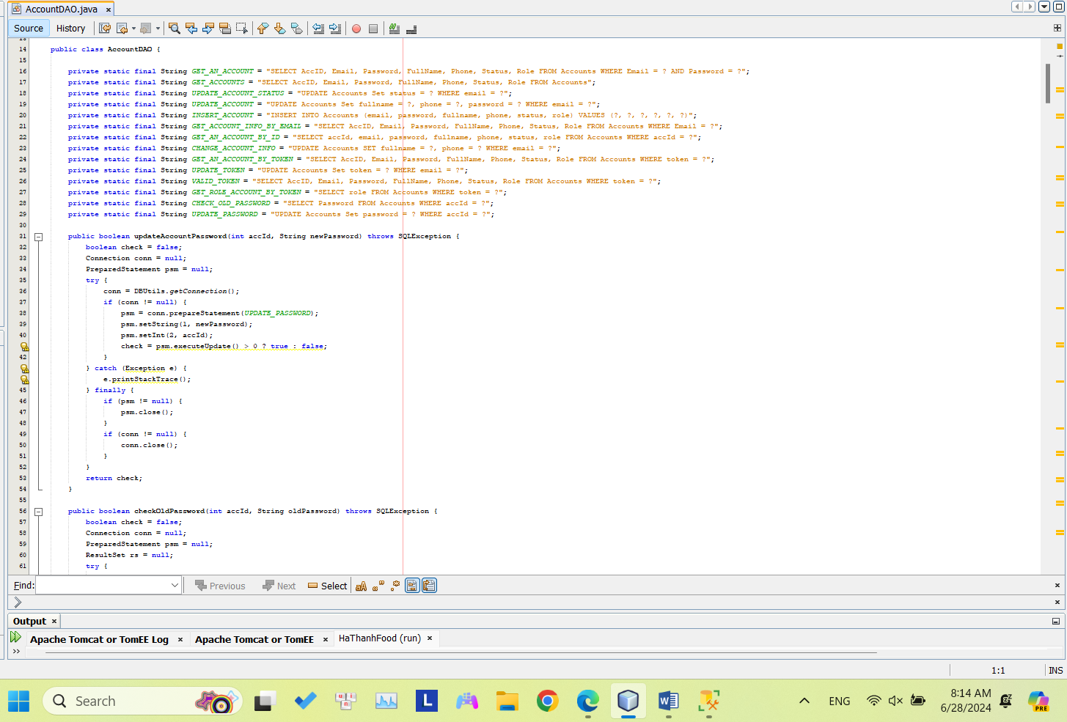

**- View**: The view //is responsible for rendering the user interface. On the application, this includes JSP files like admin.jsp, home.jsp, user.jsp,.... These files display data from the model to the user and capture user input.

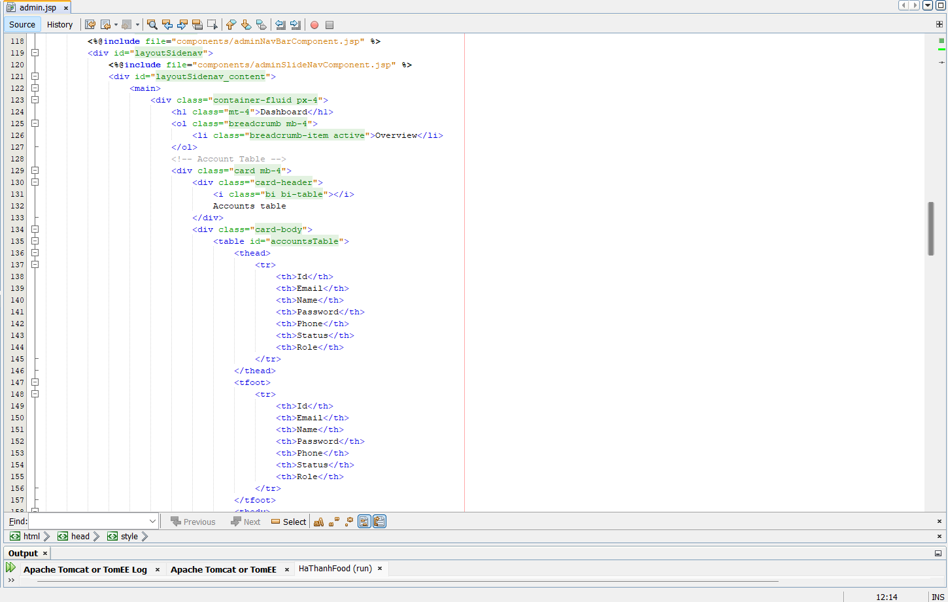

**Controller**: The controller manages user input and modifies the model as needed. In the application, this encompasses servlets such as ChangeOrderController, UpdateProductController, etc. These servlets handle HTTP requests, execute operations using the DAOs, and direct the request to the suitable JSP for rendering the response. 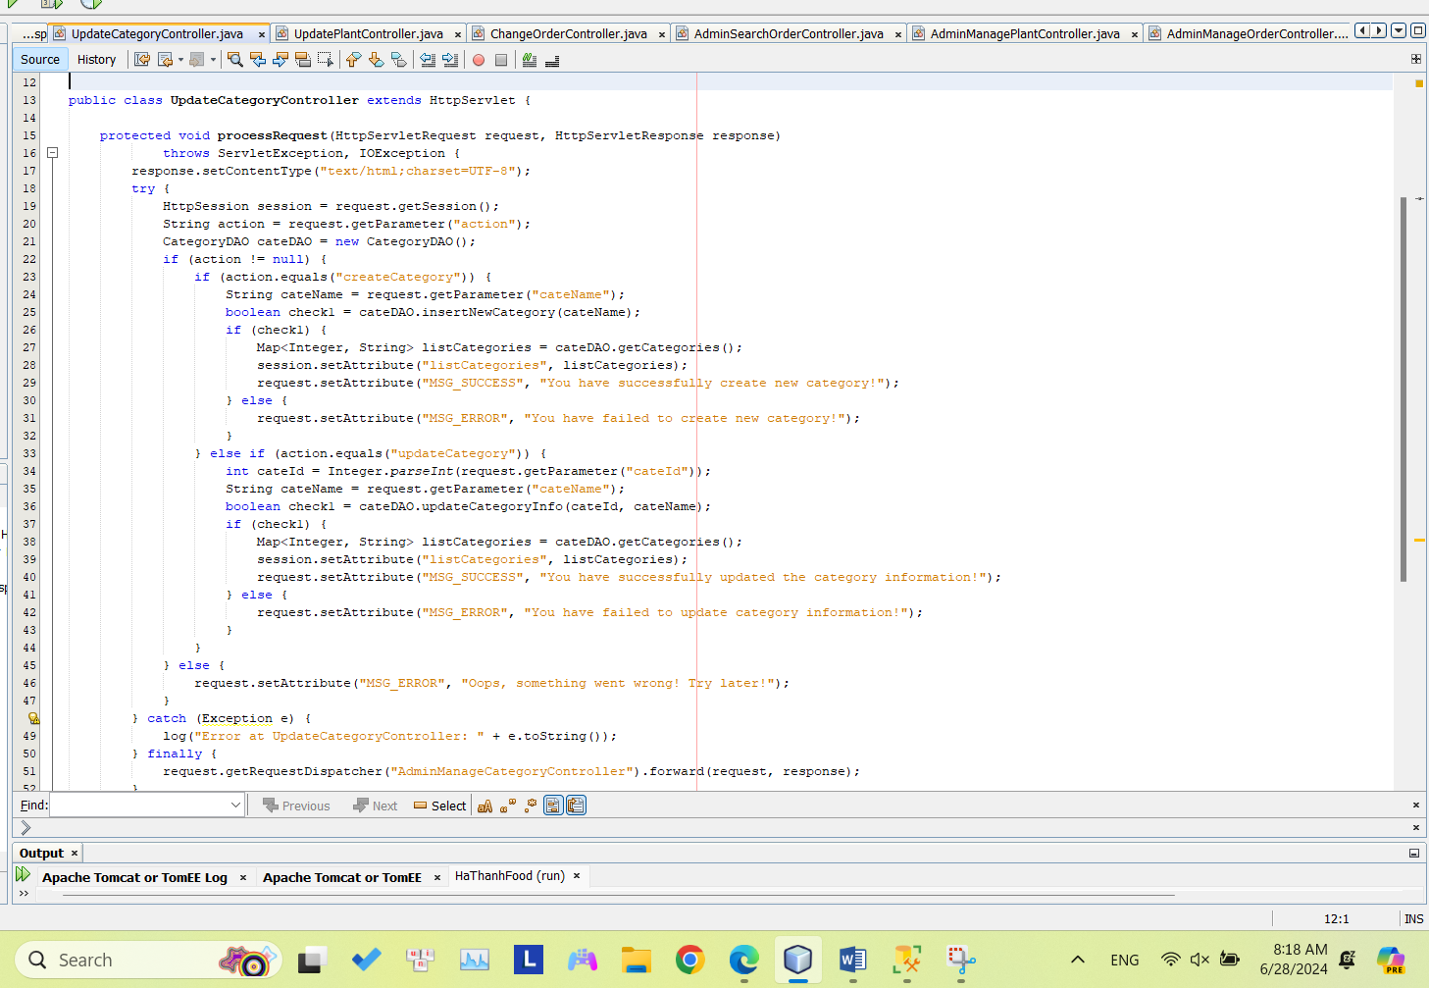

**II. Build Project and Function of Project**

1. Database

- Database Diagram:

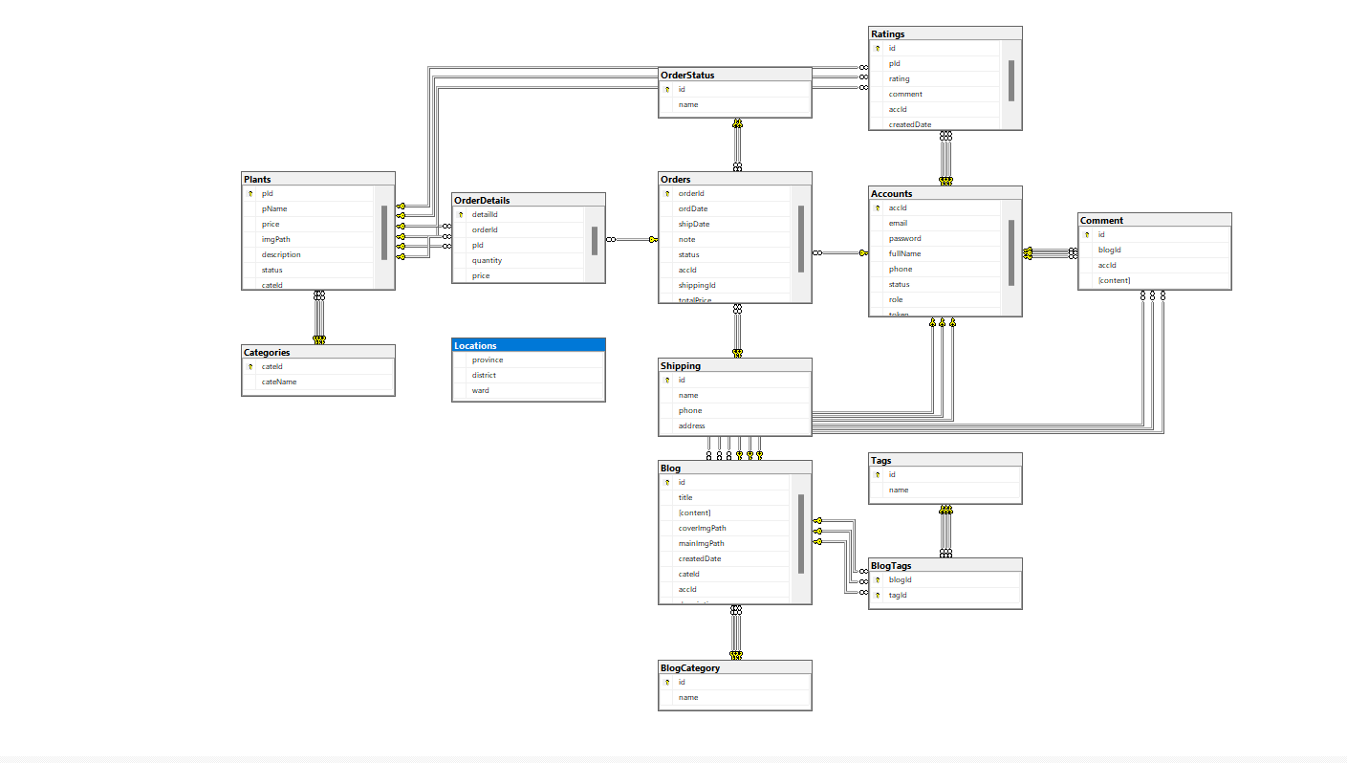

- Database Name: HaThanhFood

+ dbo.Accounts

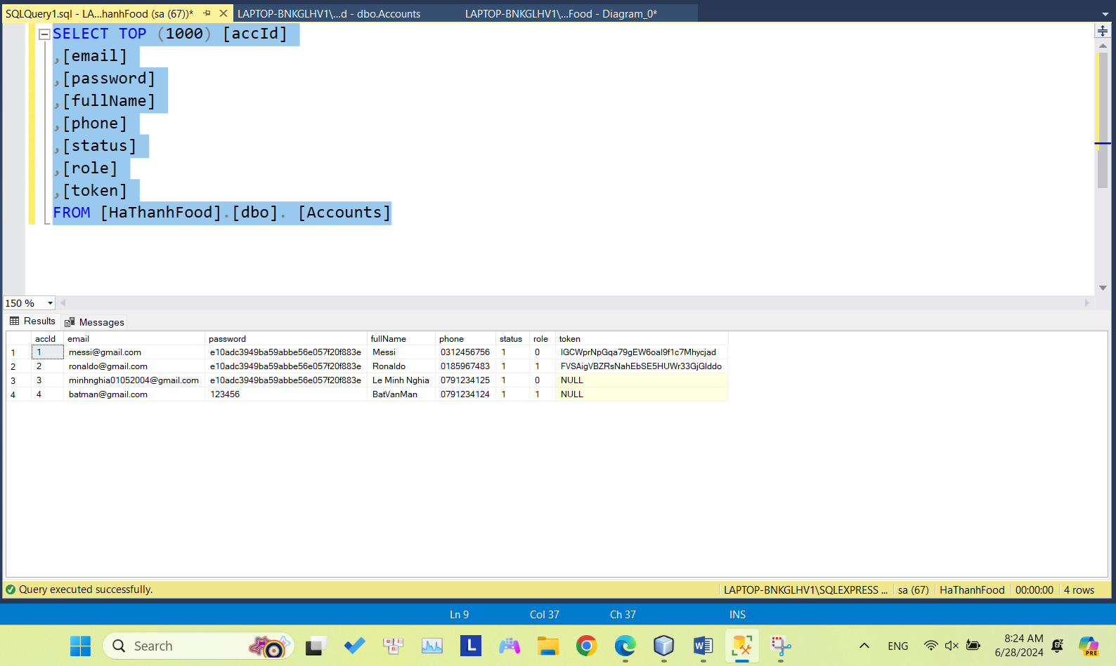

+dbo.Blog

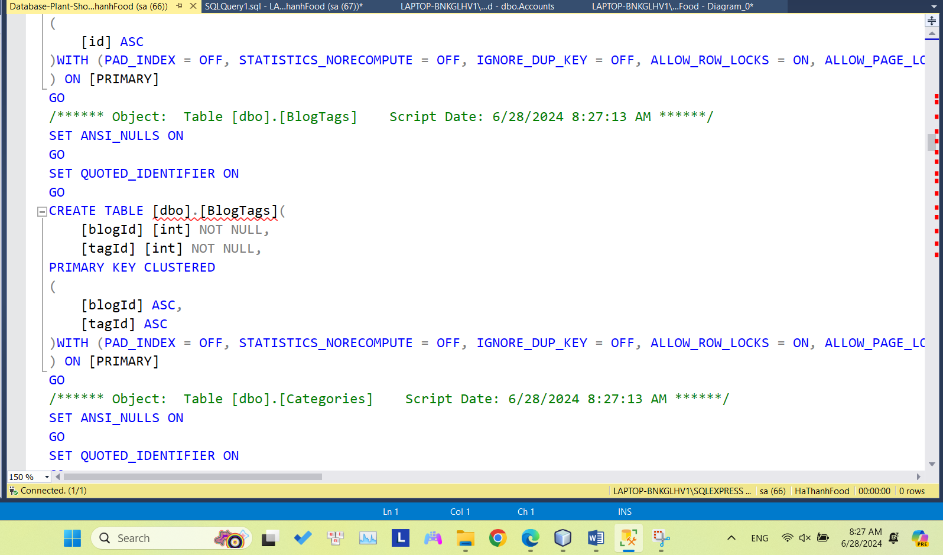

+ dbo.BlogCategory, dbo.BlogTags

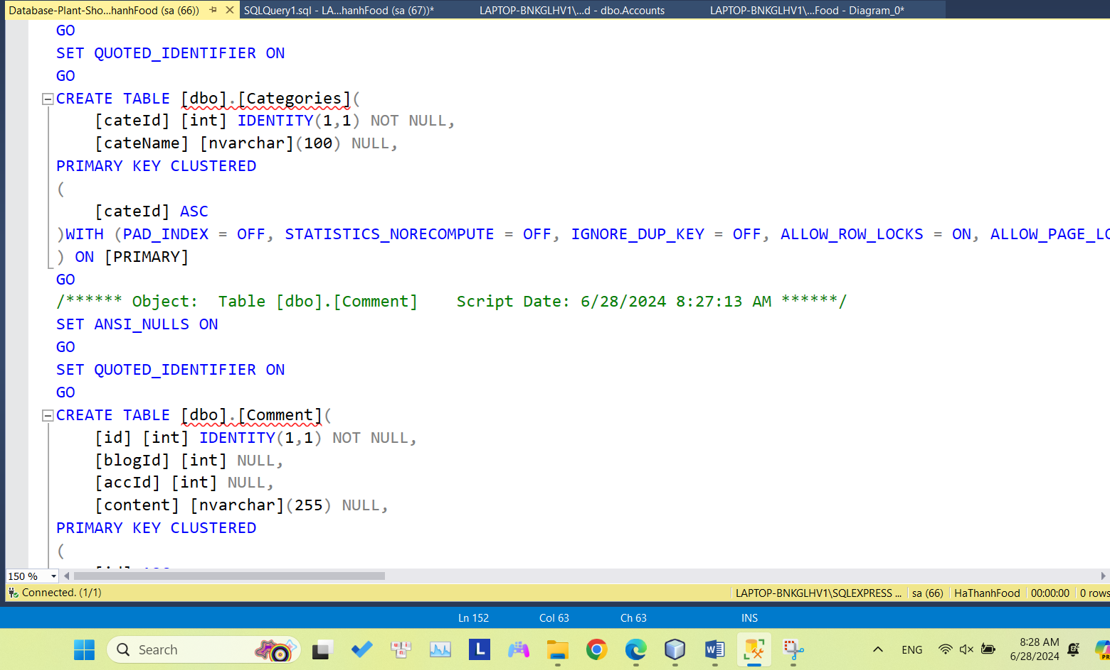

+ dbo.Categories

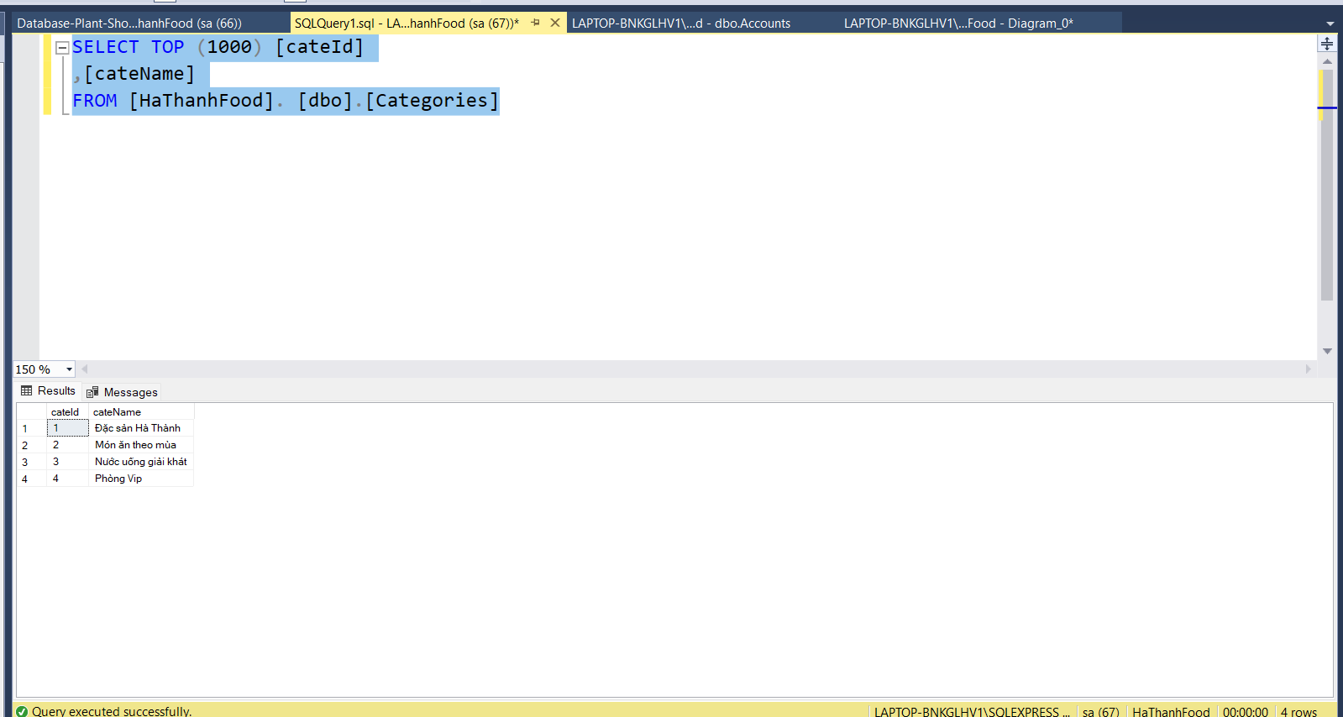

+ dbo.Comment, dbo.Locations

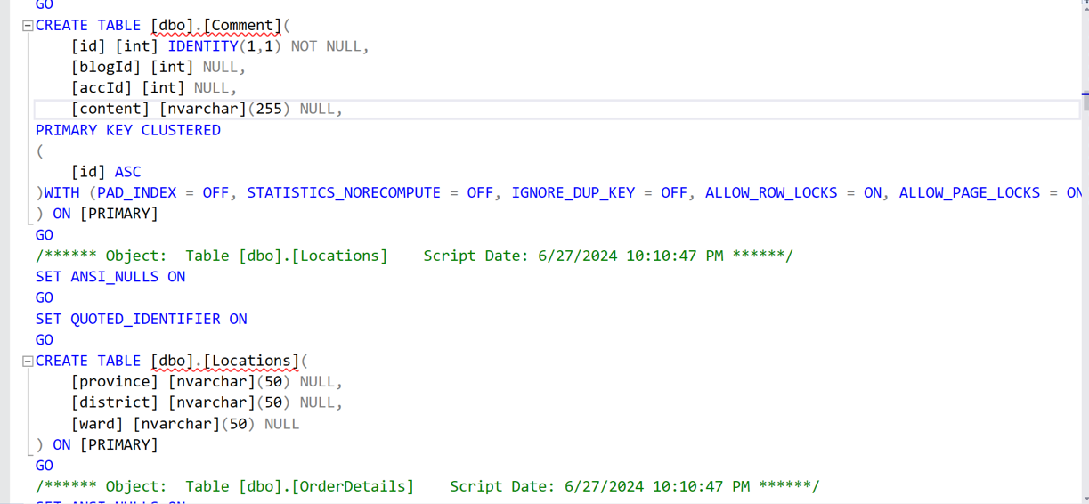

+ dbo.OrderDetails

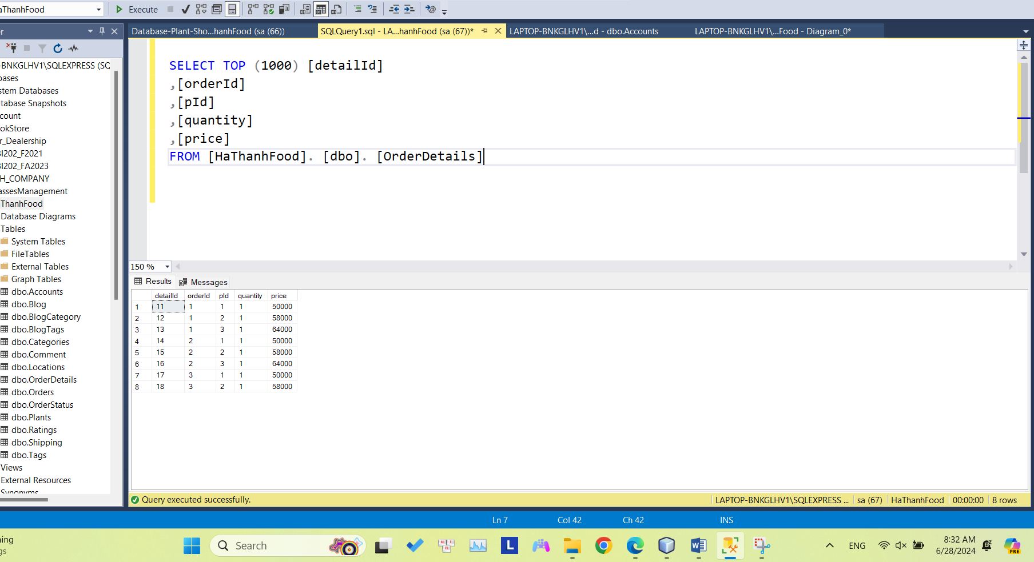

+ dbo.Orders

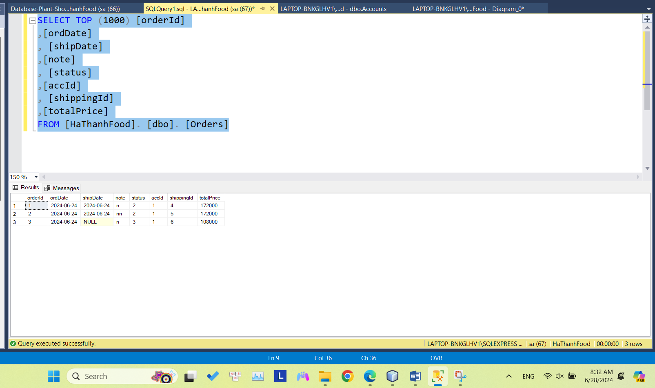

+ dbo.OrderStatus

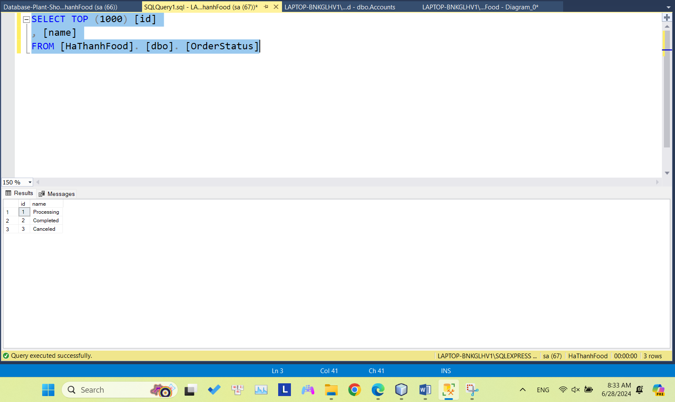

+ dbo.Products

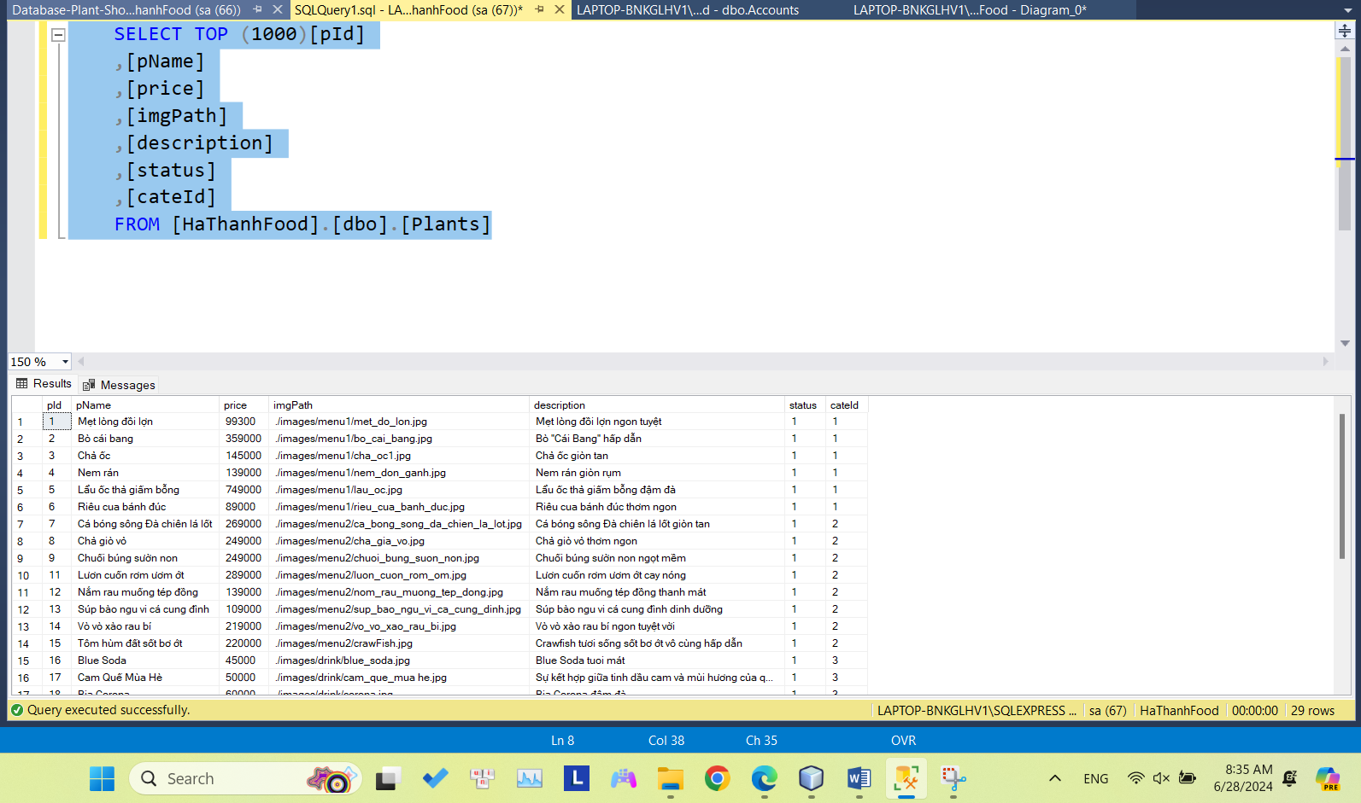

+ dbo.Shipping

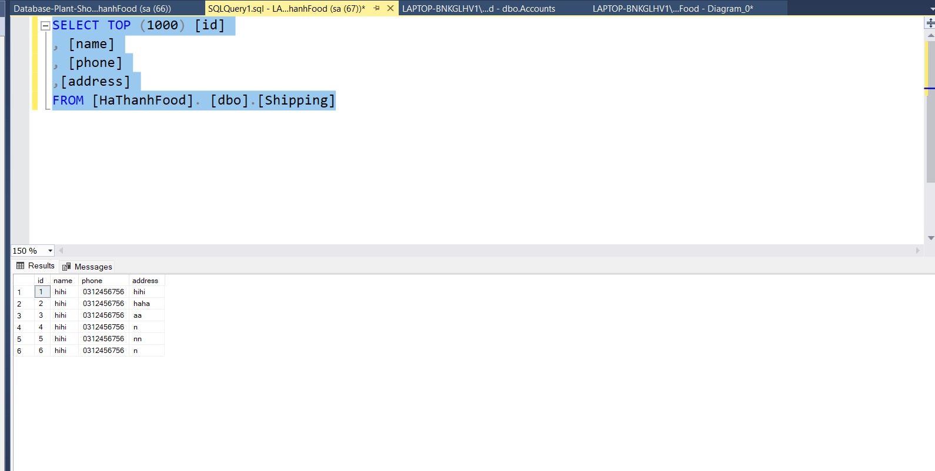

+ dbo.Ratings, dbo.Tags

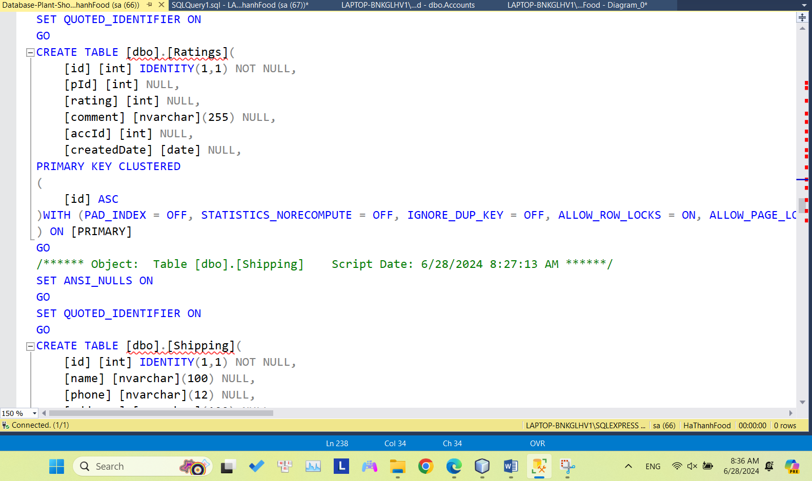

## User interface

- Home page

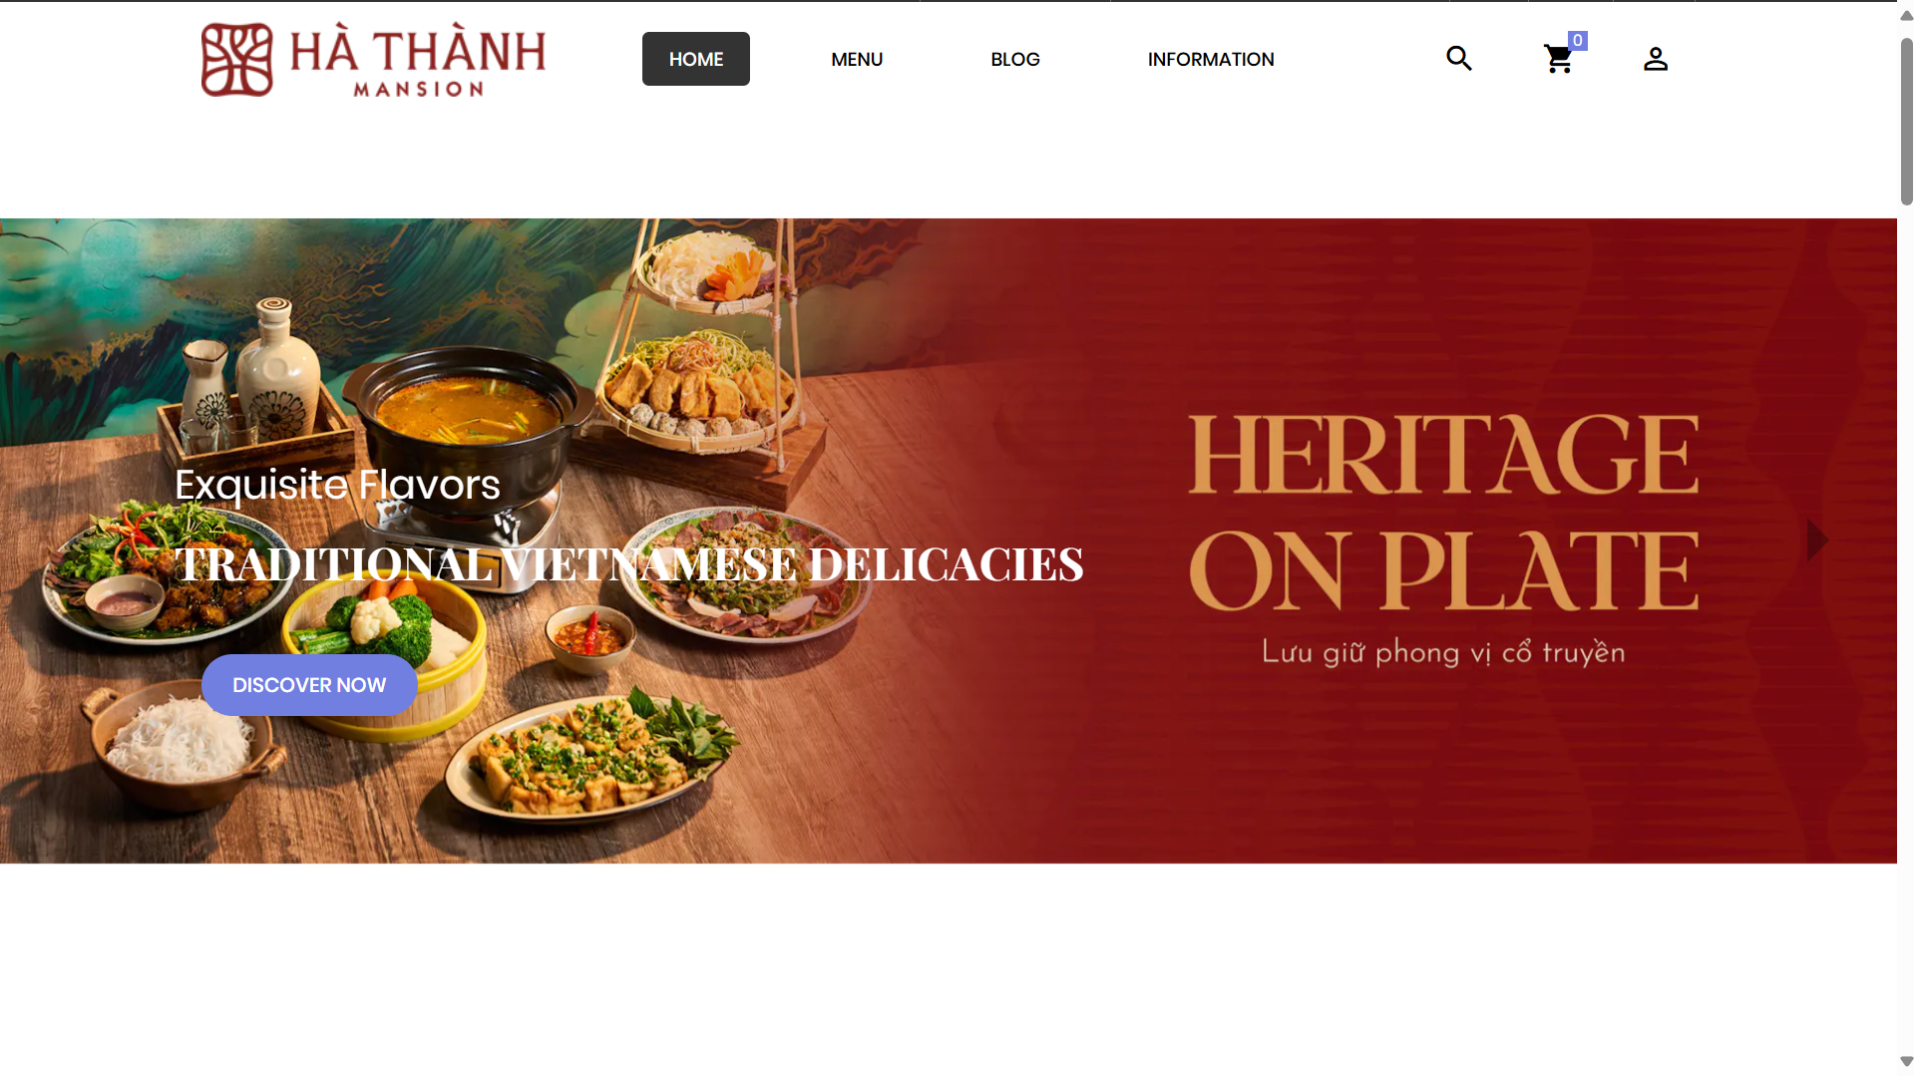

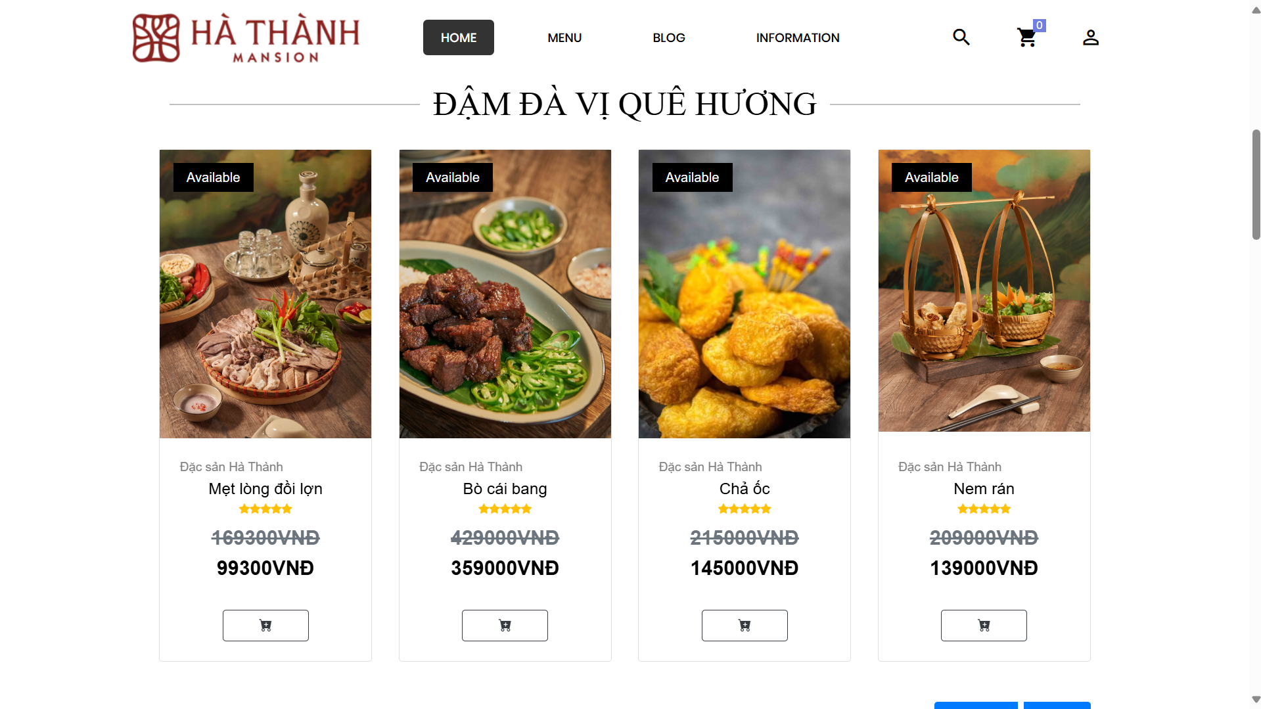

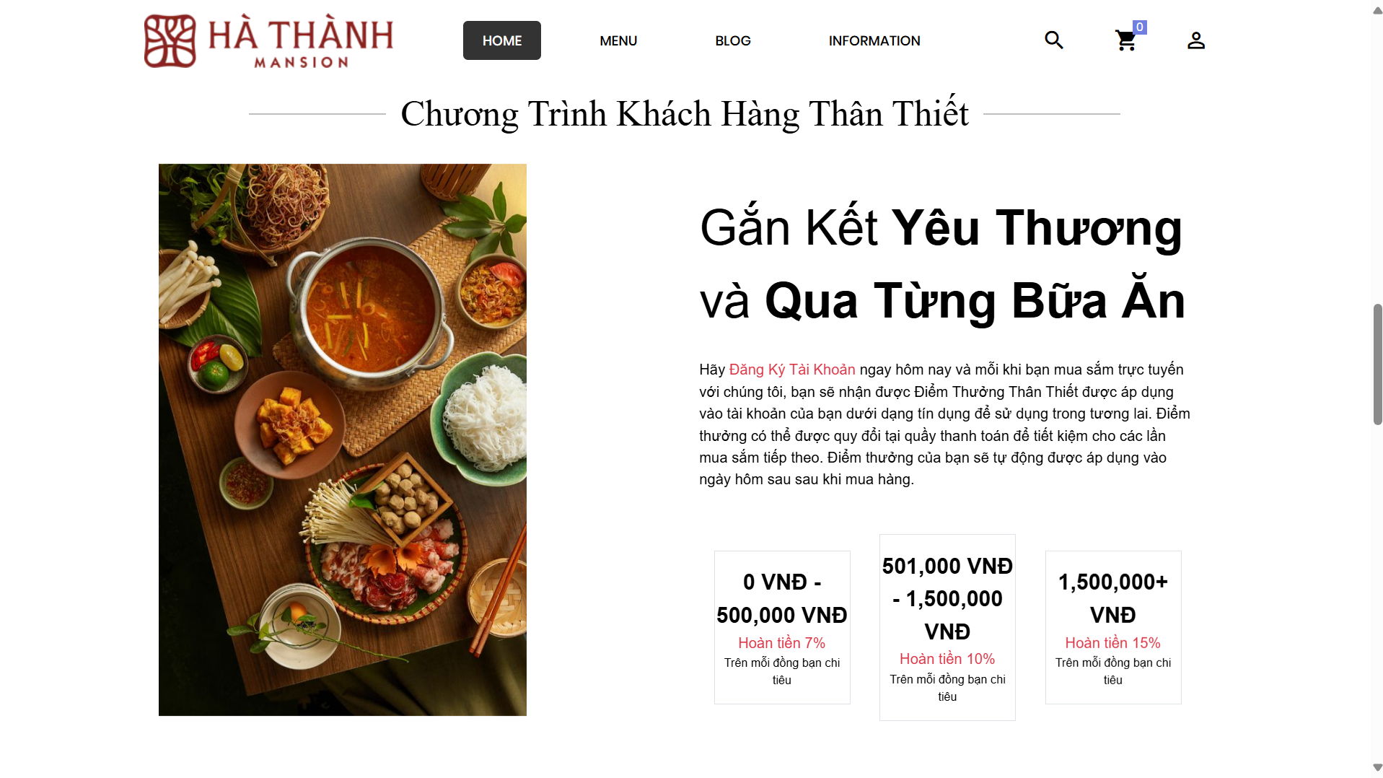

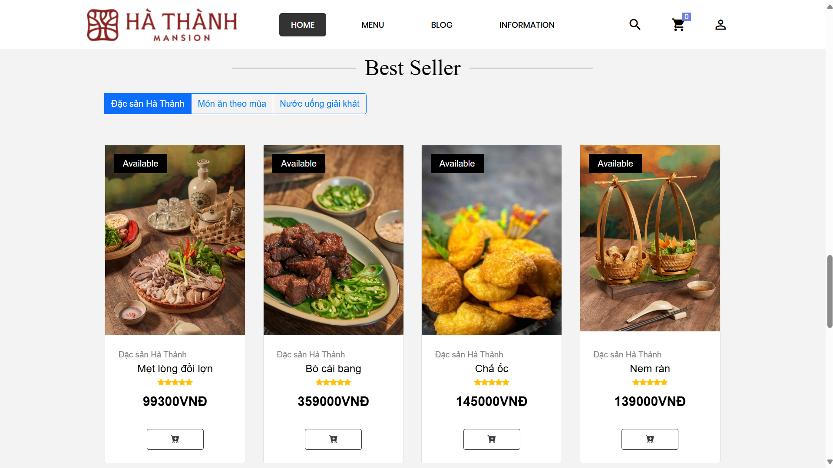

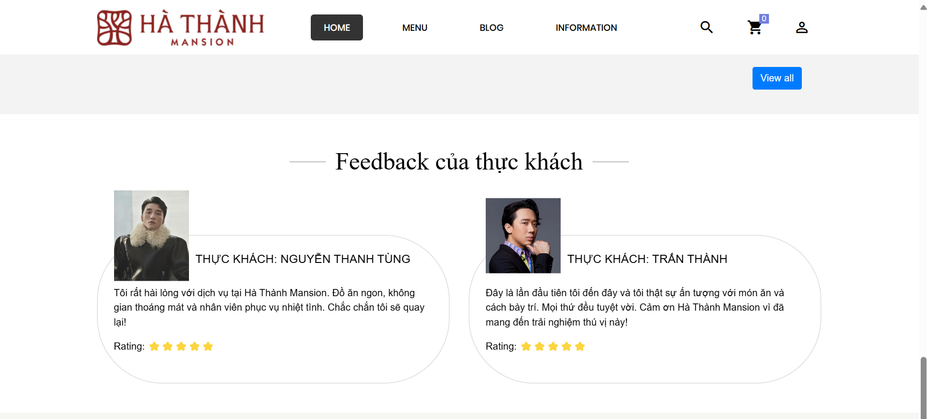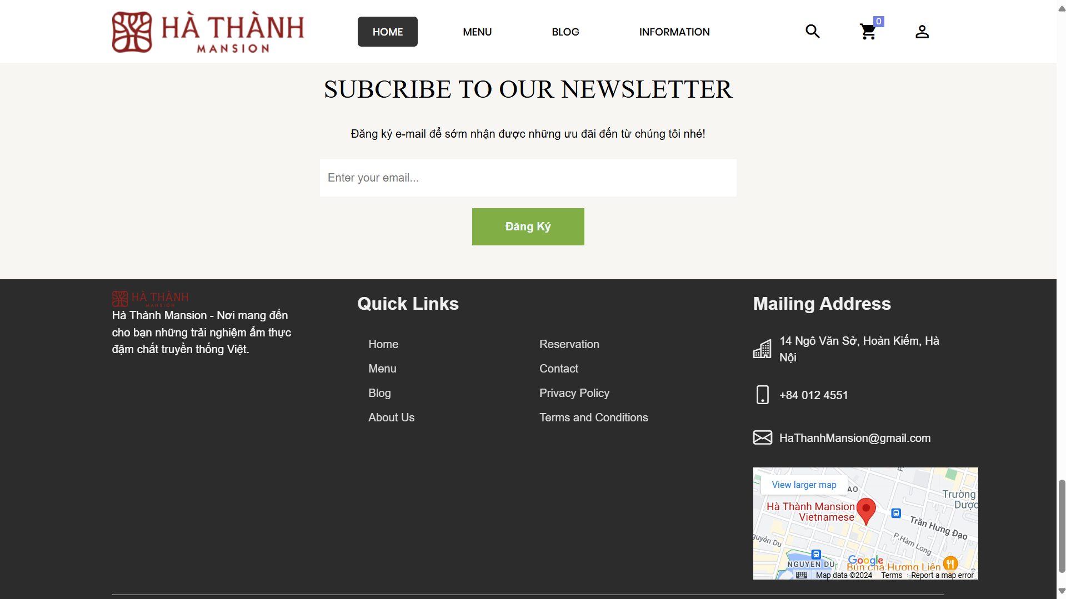

-Menu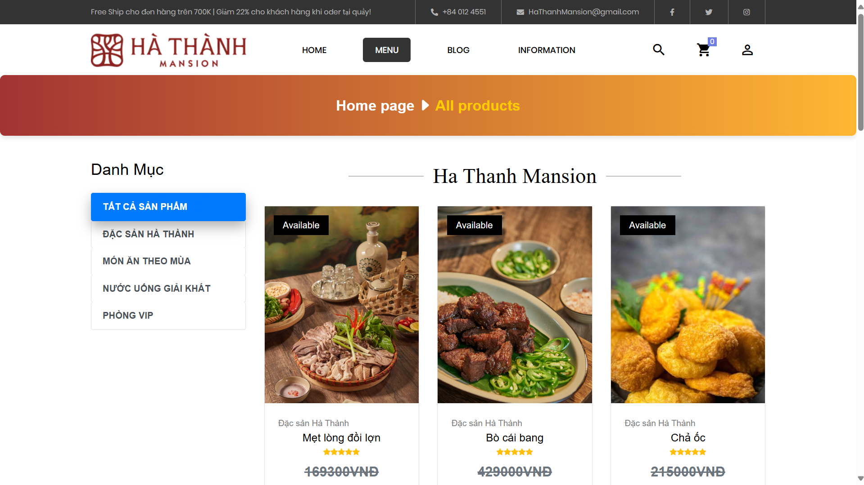

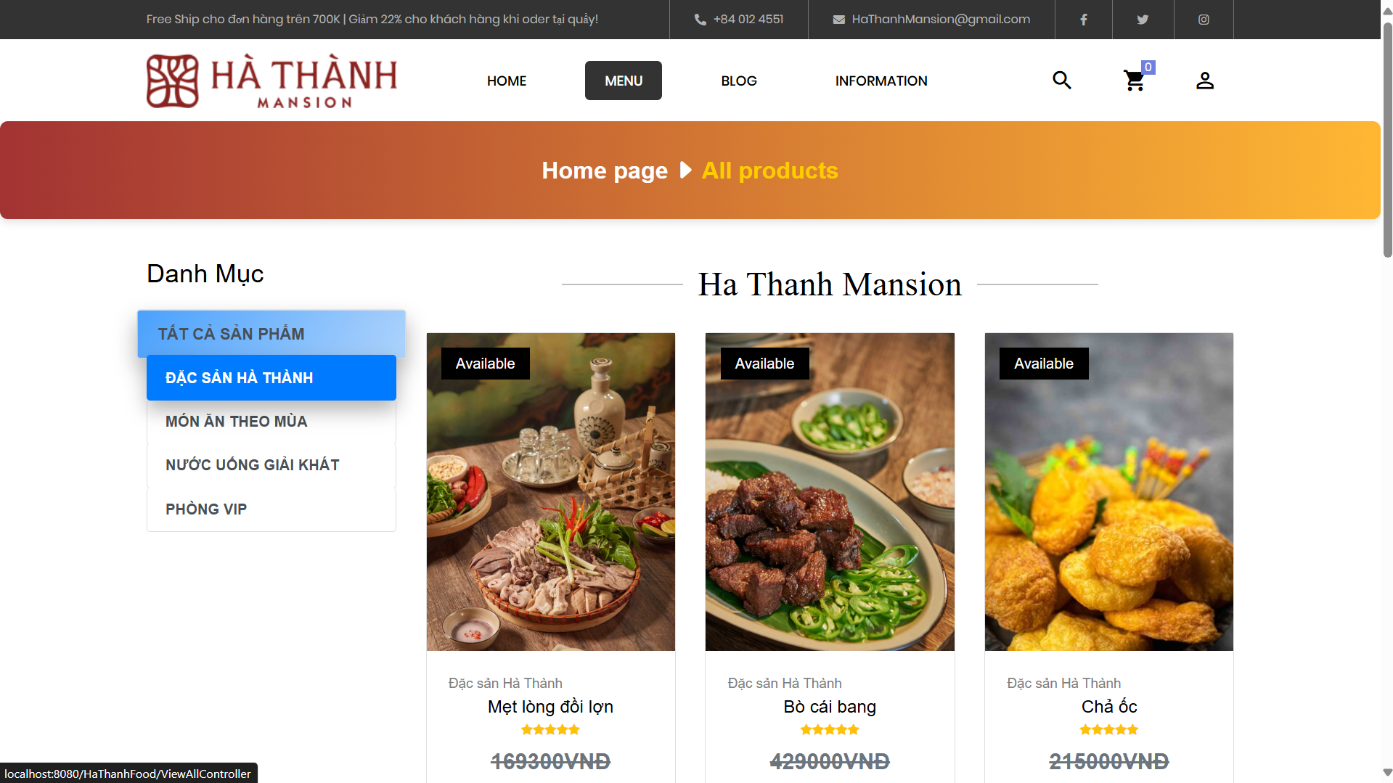

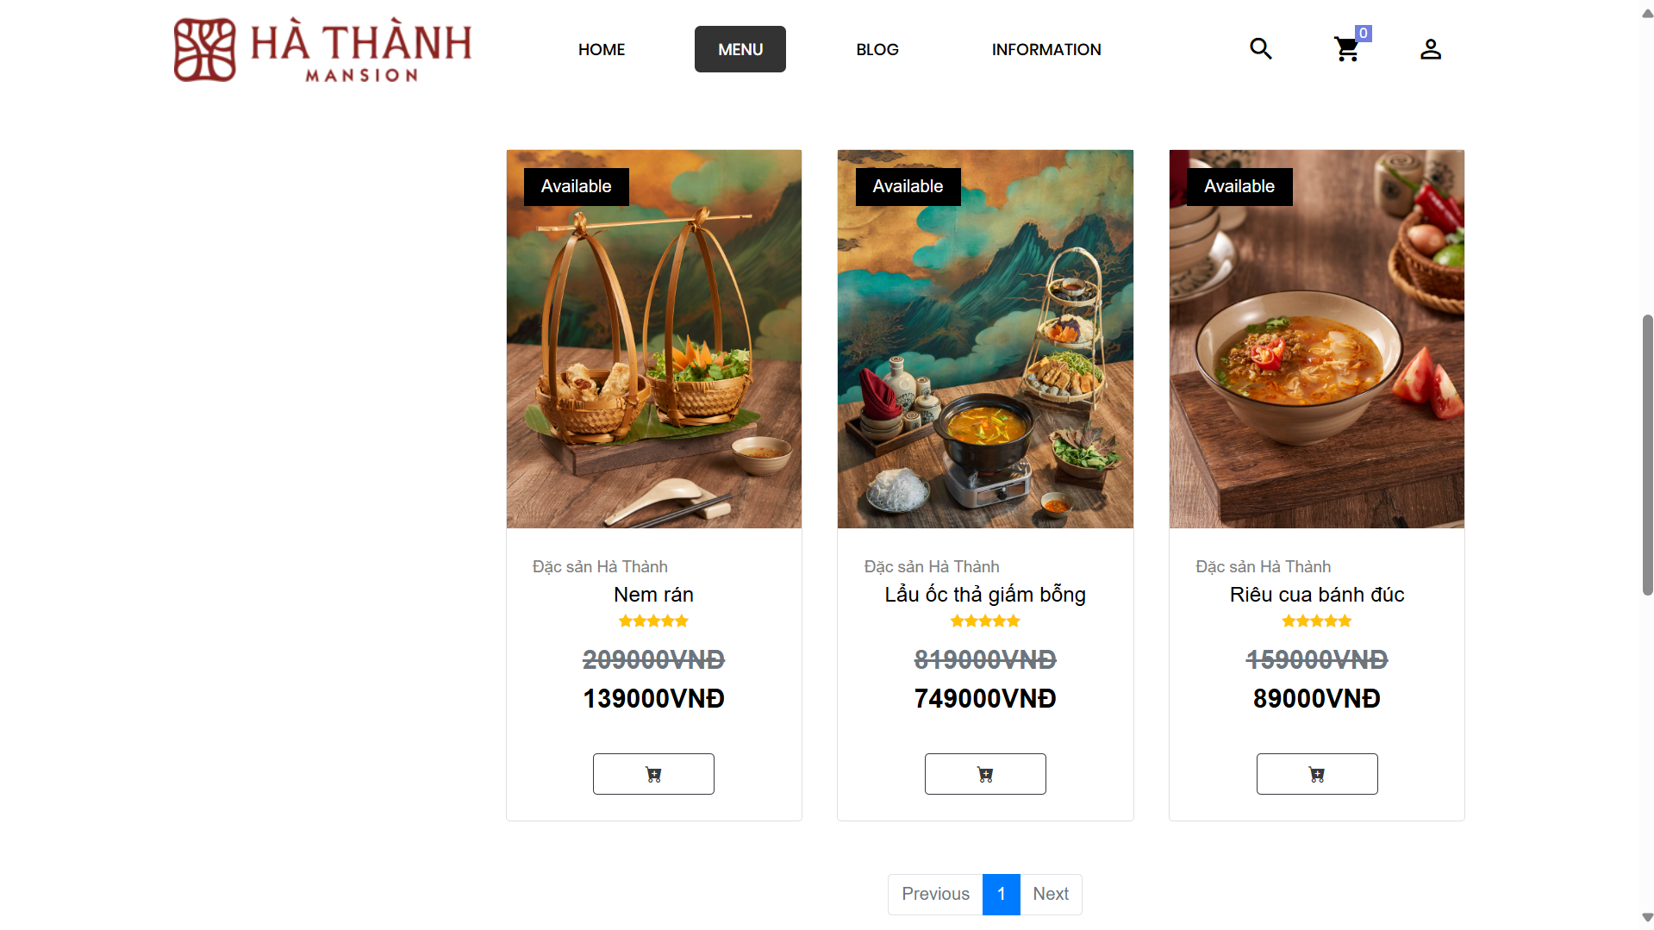

+Blog

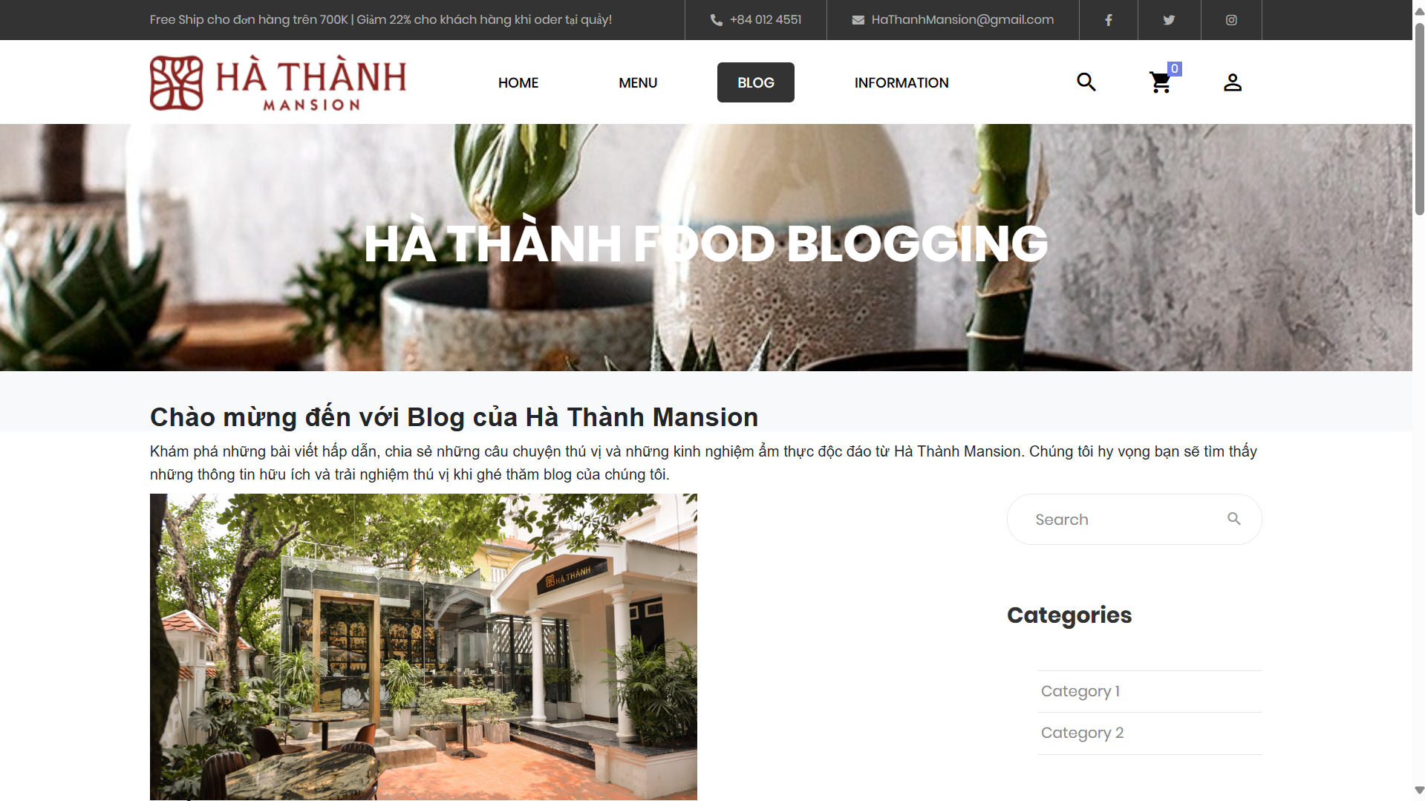

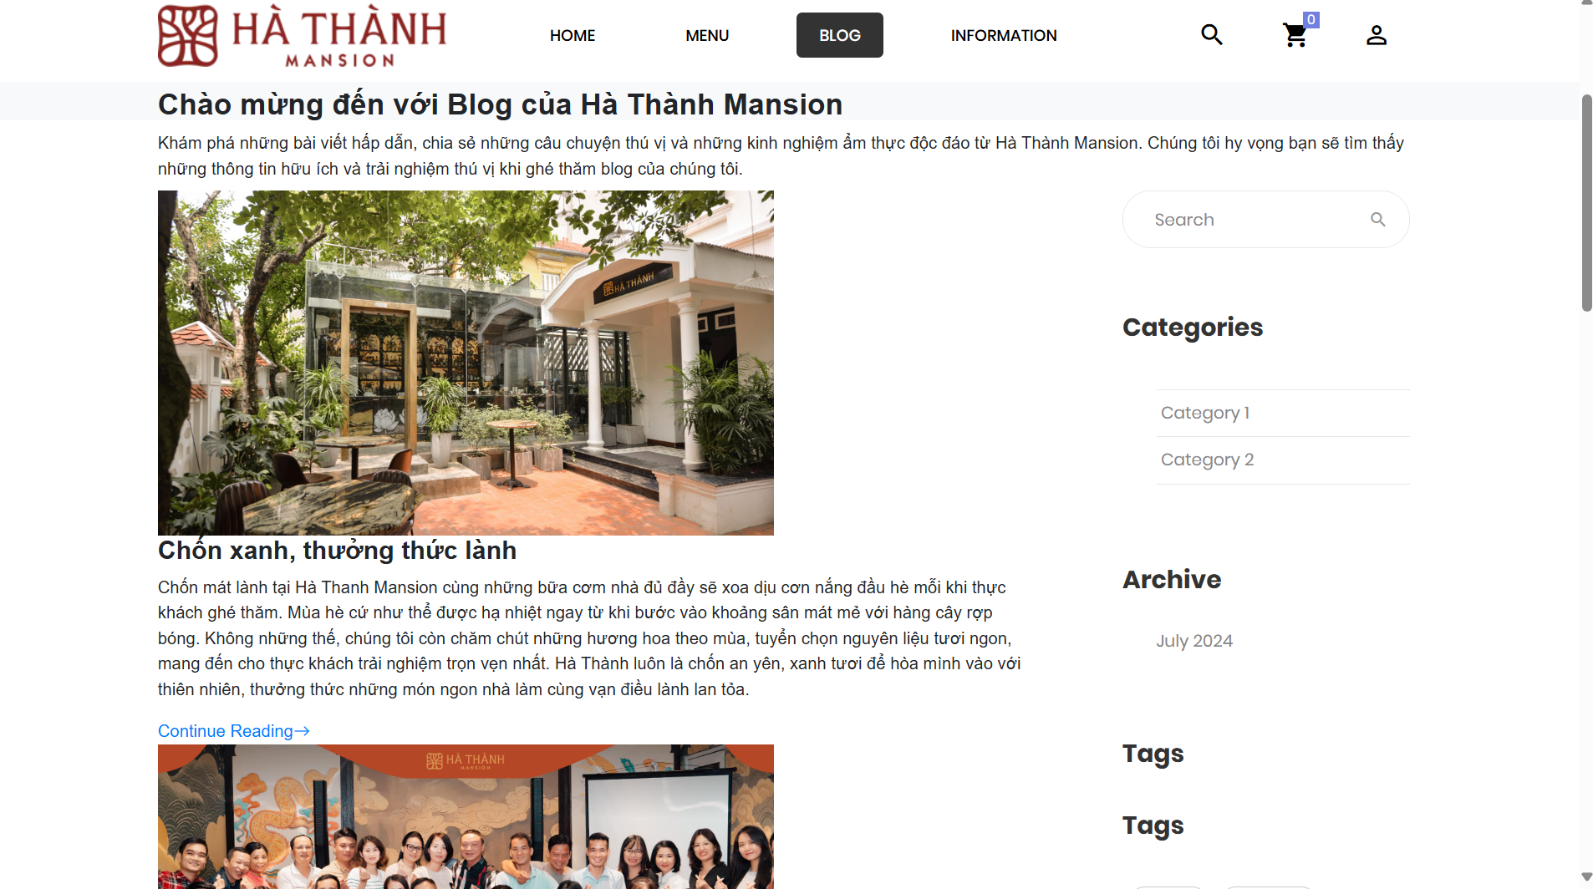+LOGIN

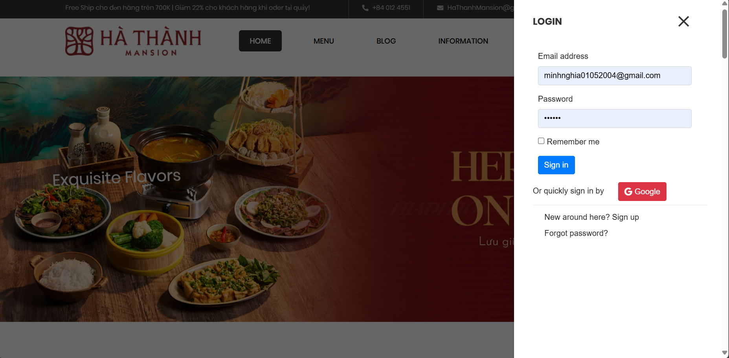

+Register  
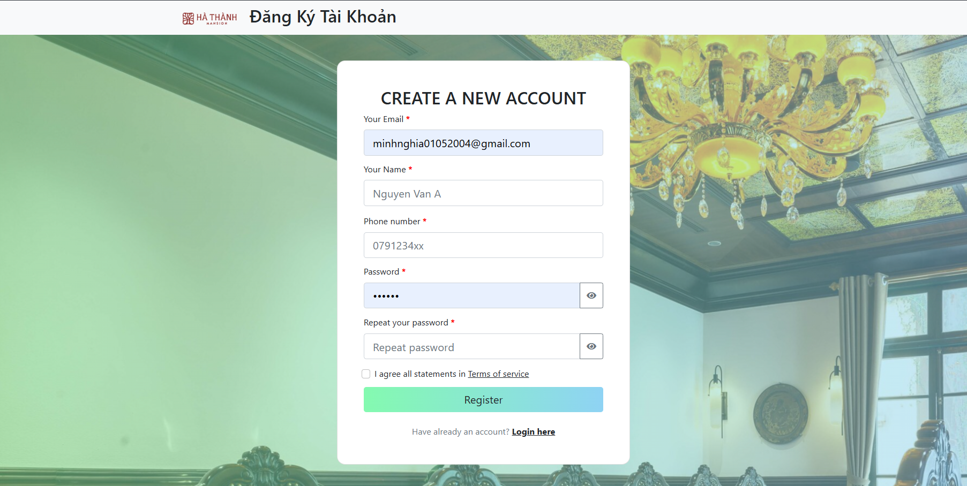

+INFORMATION

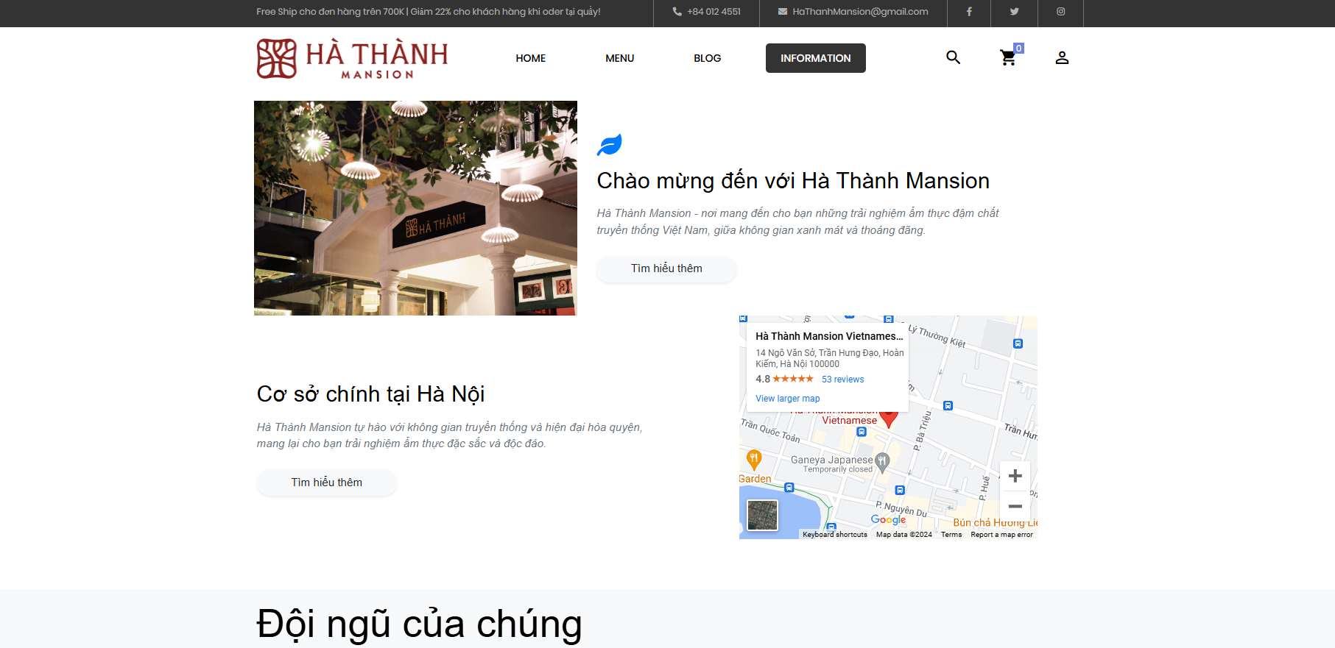

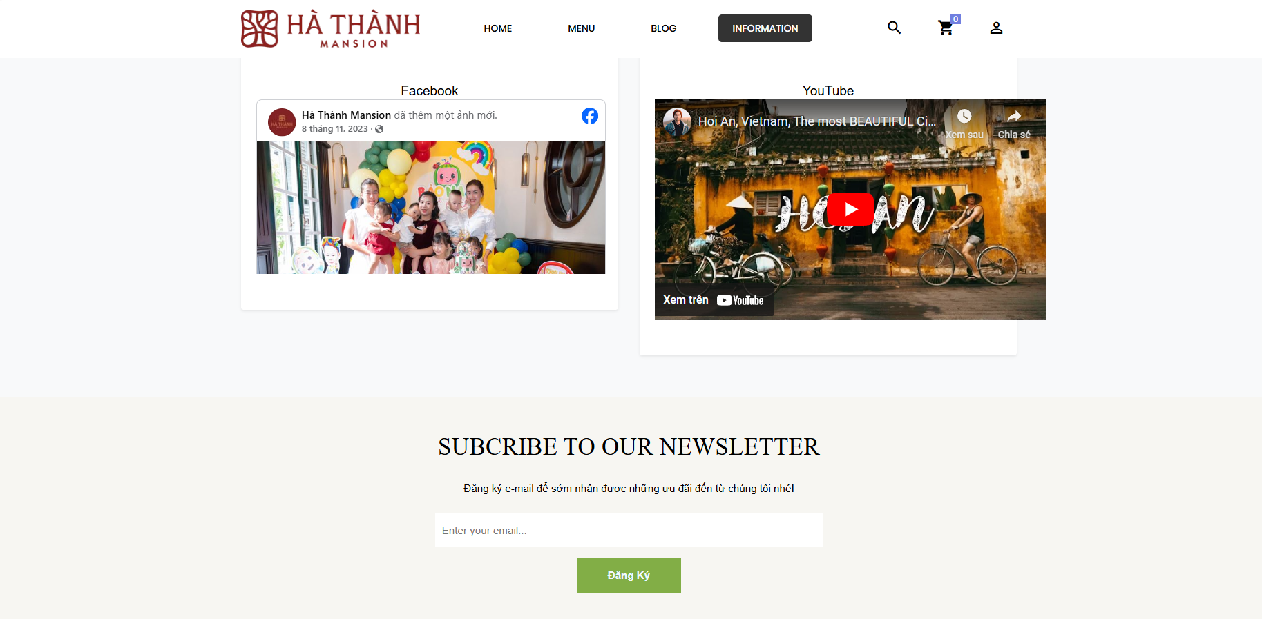

- Search products :  
ex: Search: NEM

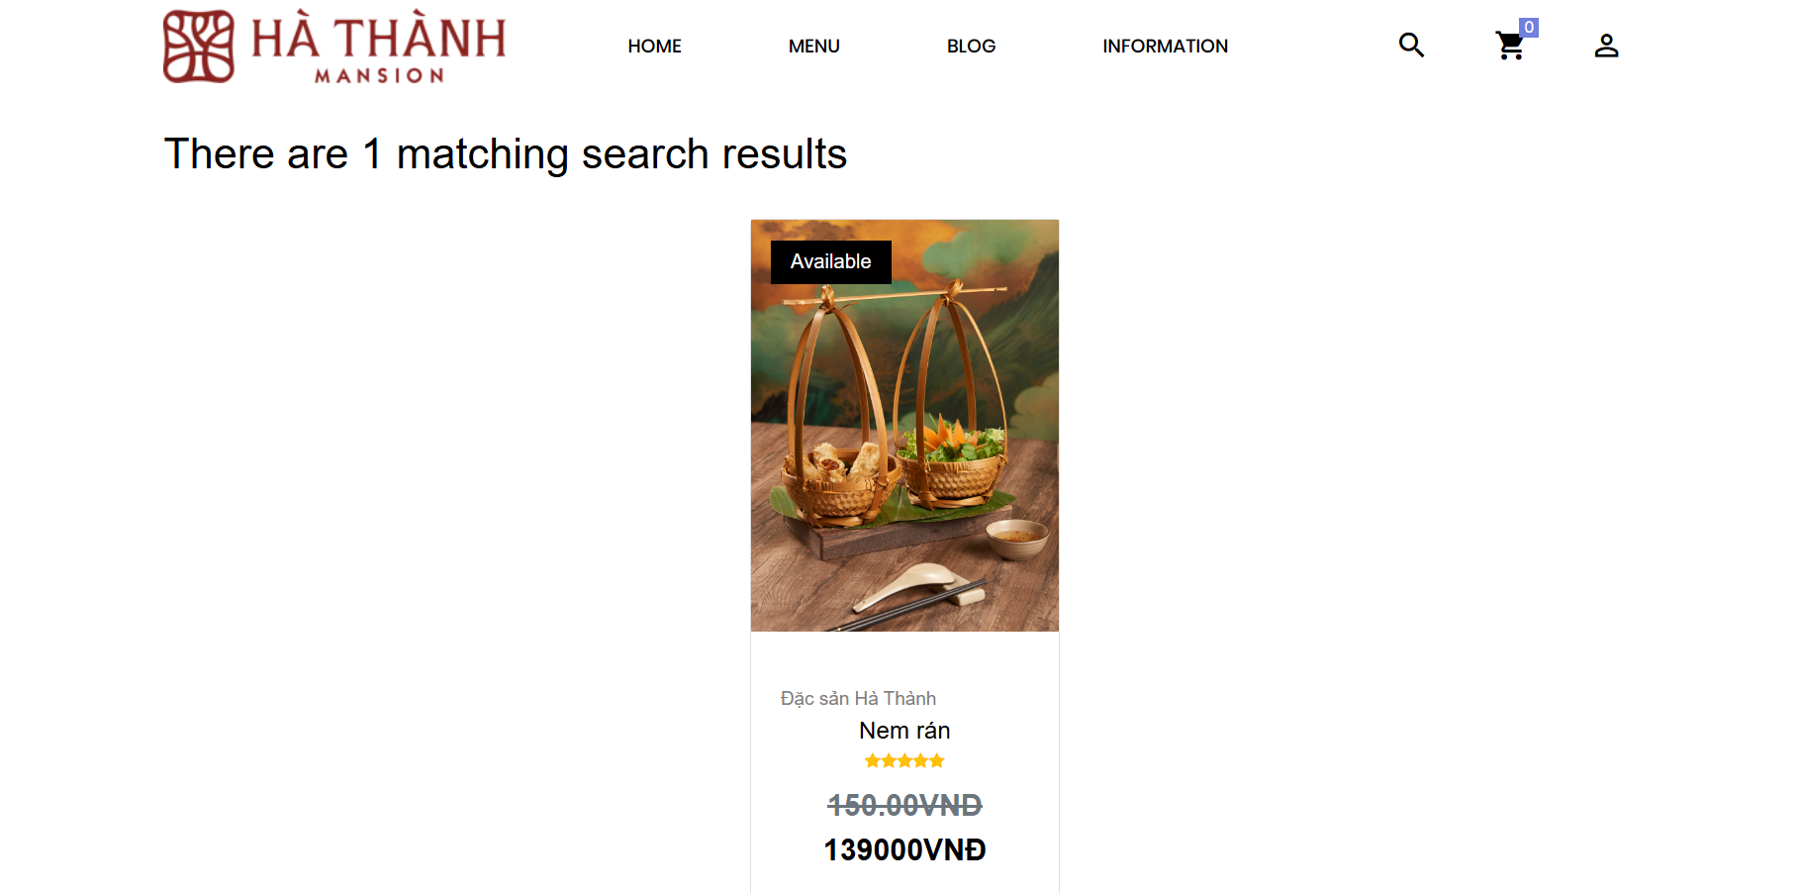

- Product detail

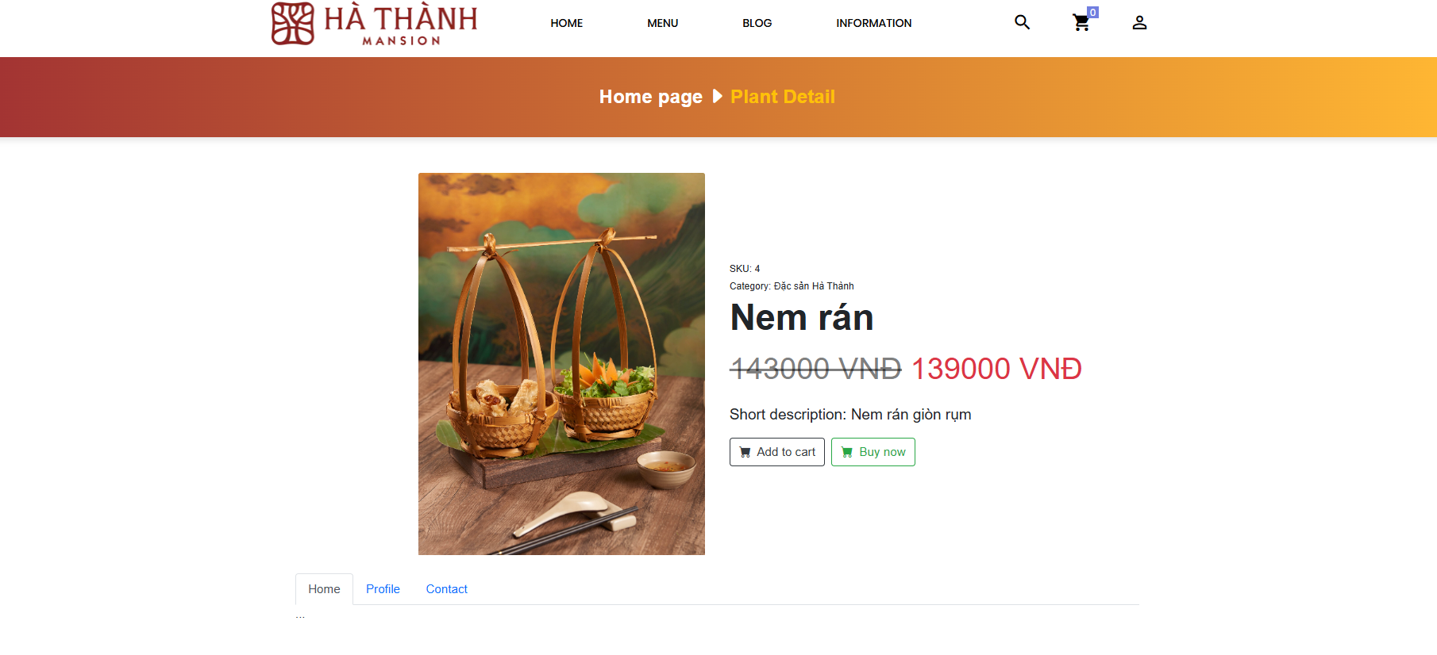

+VIEW CART

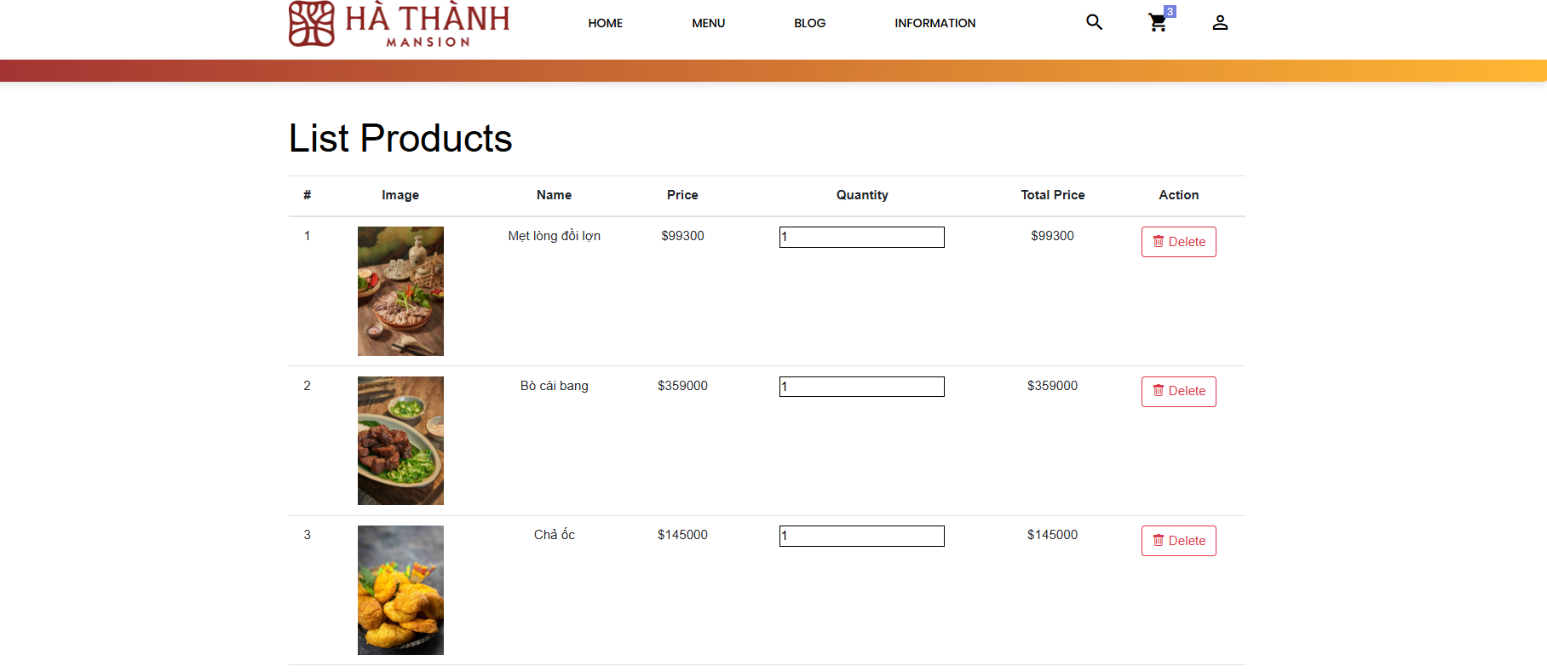

+USER ODER  
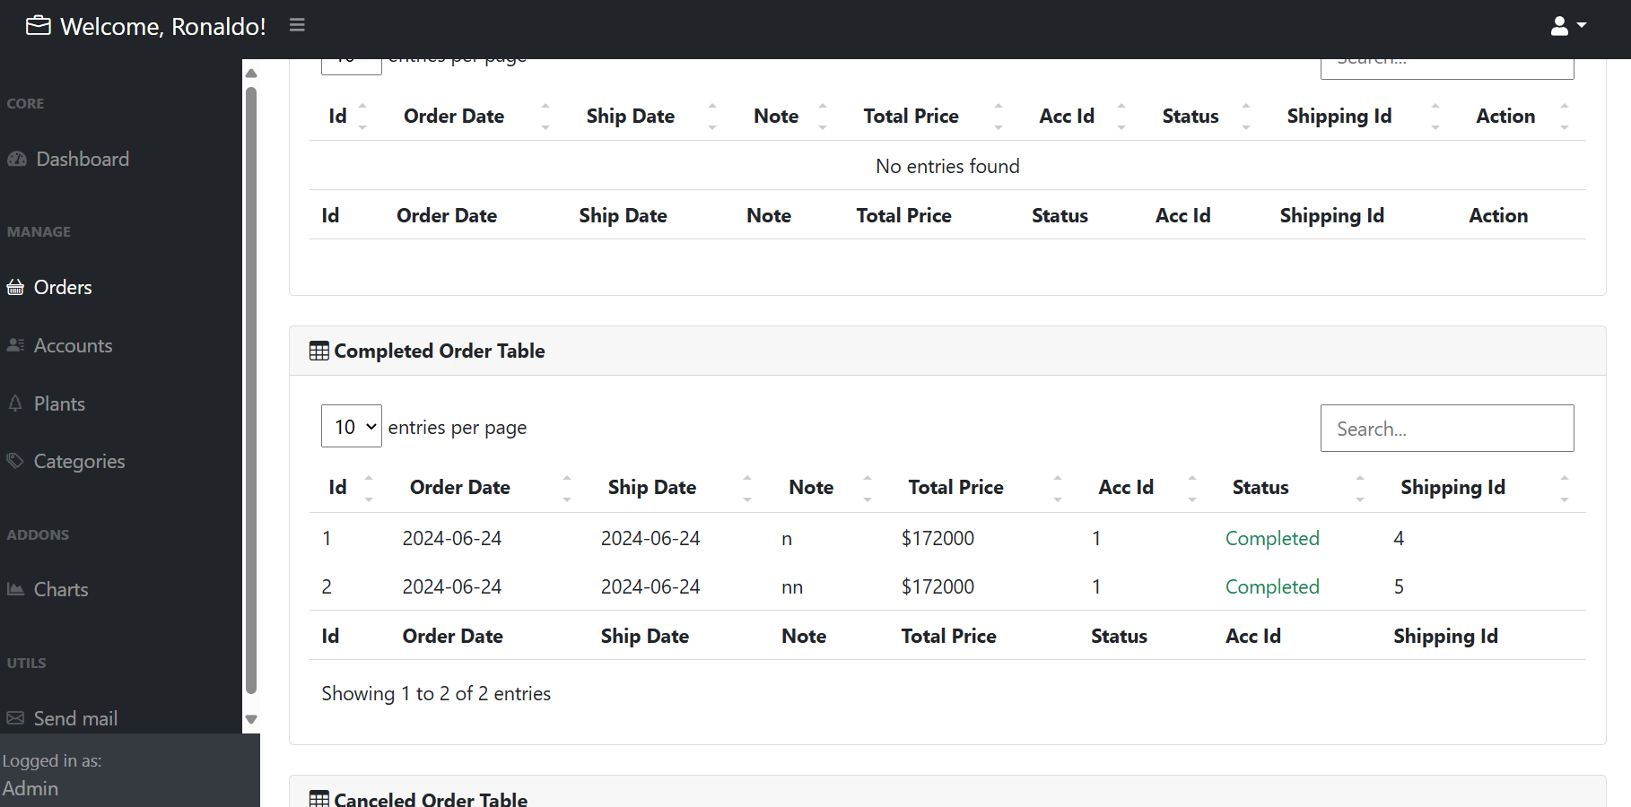

- User information

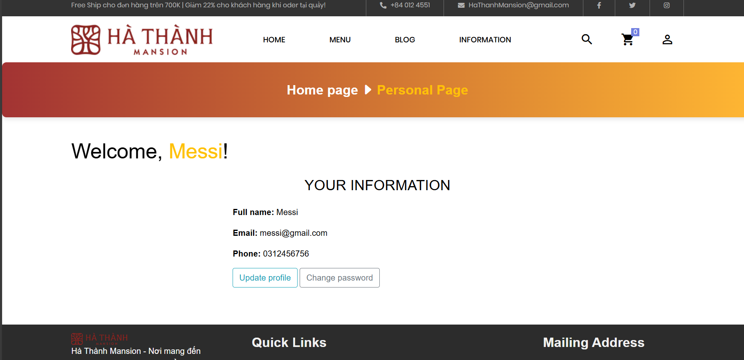

- Manage Accounts (Admin)

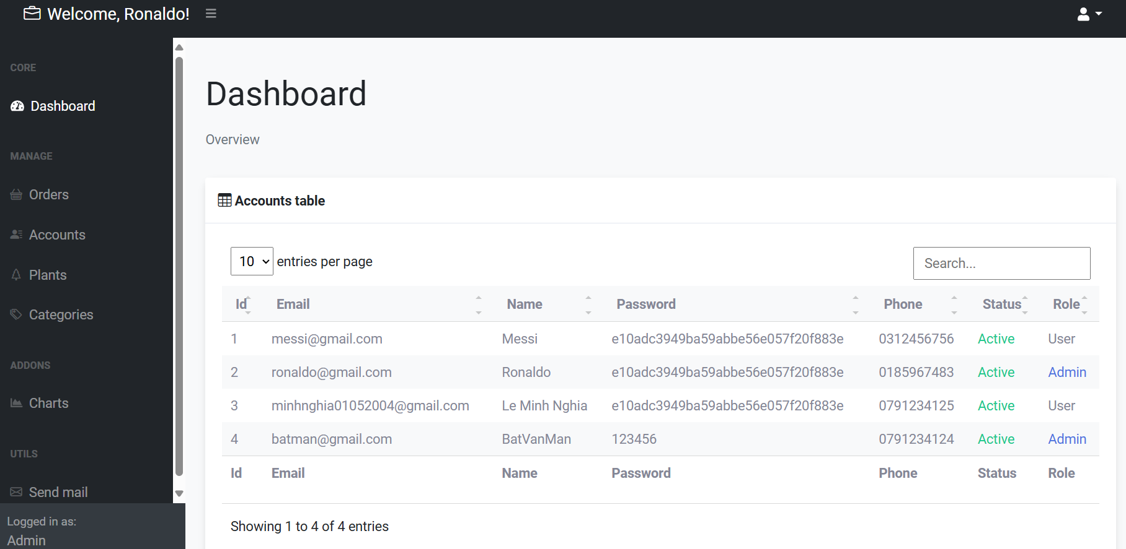

- Manage products (Admin)

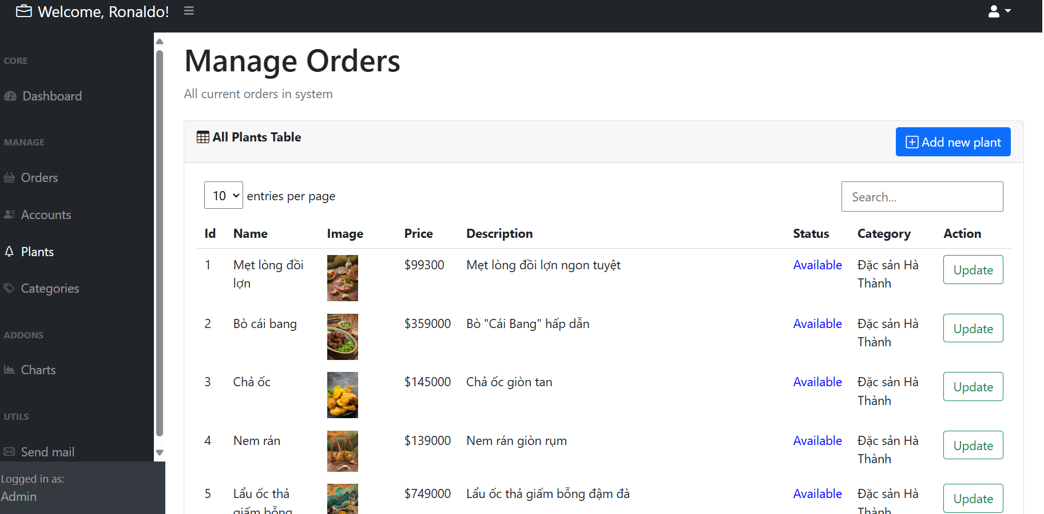

- Manage categories (Admin)

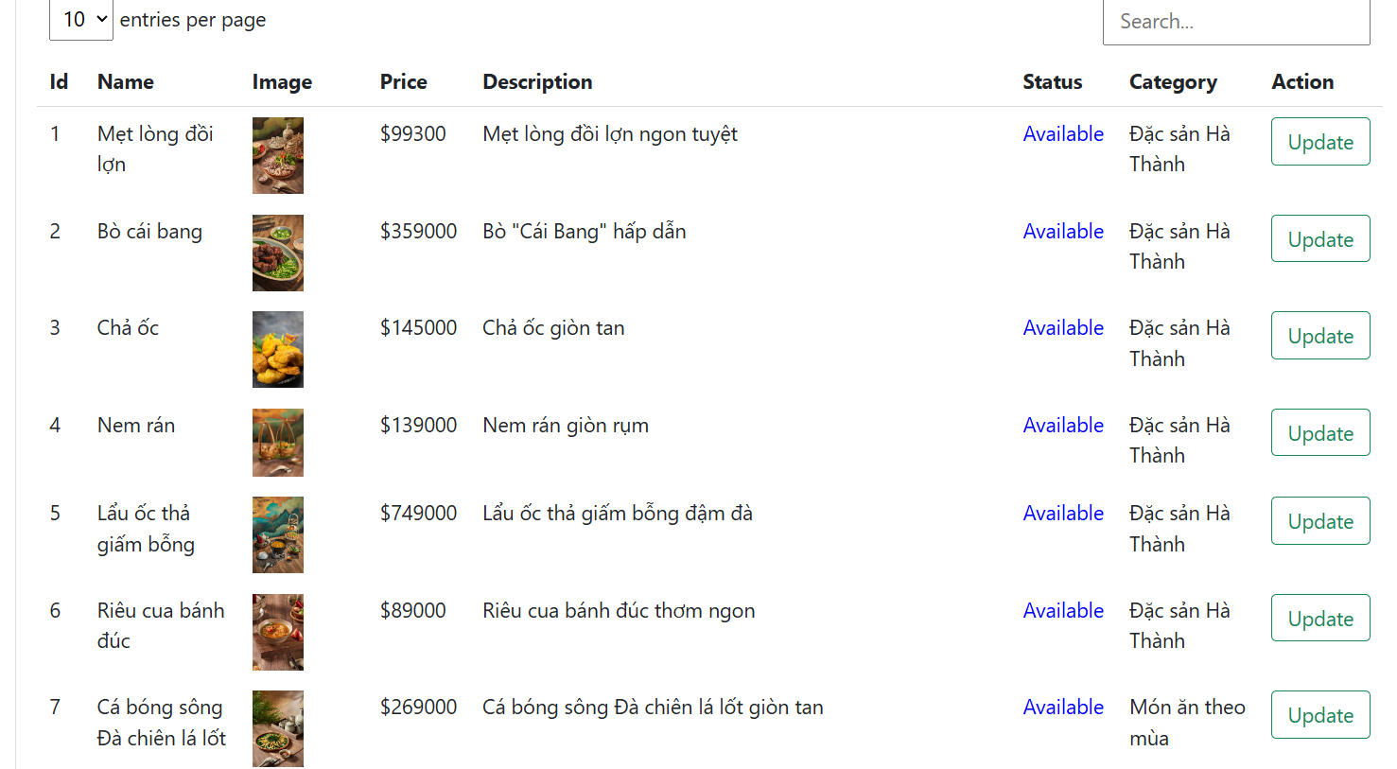

- Manage categories (Admin)

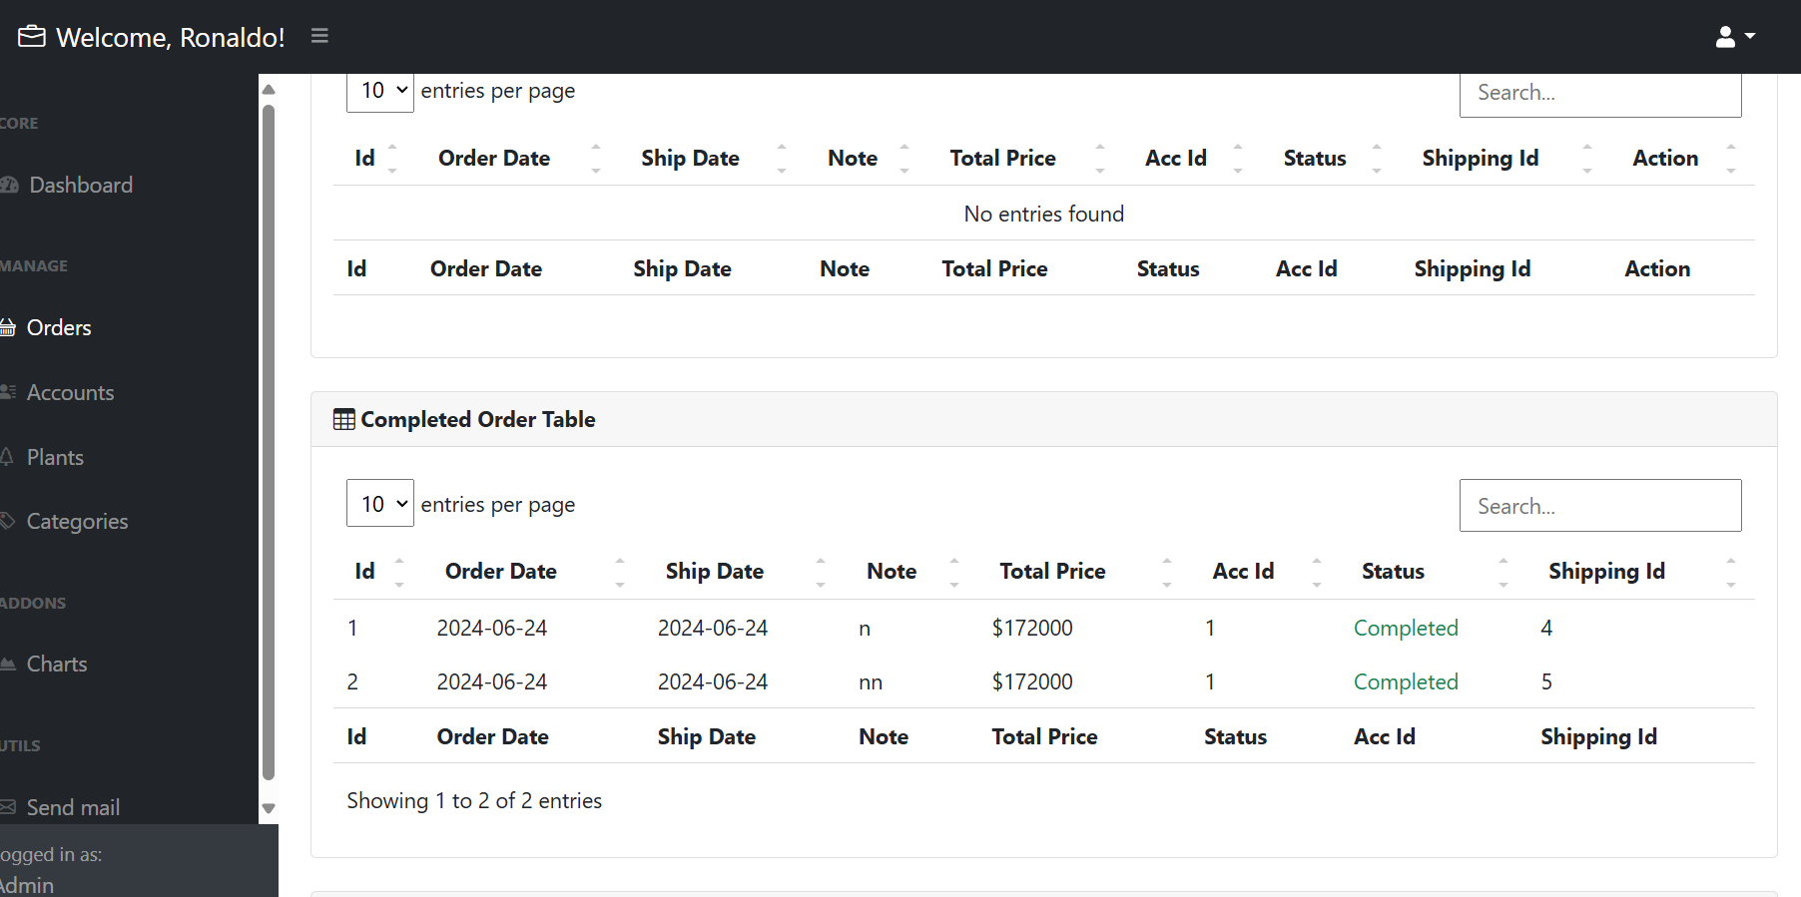

- Register

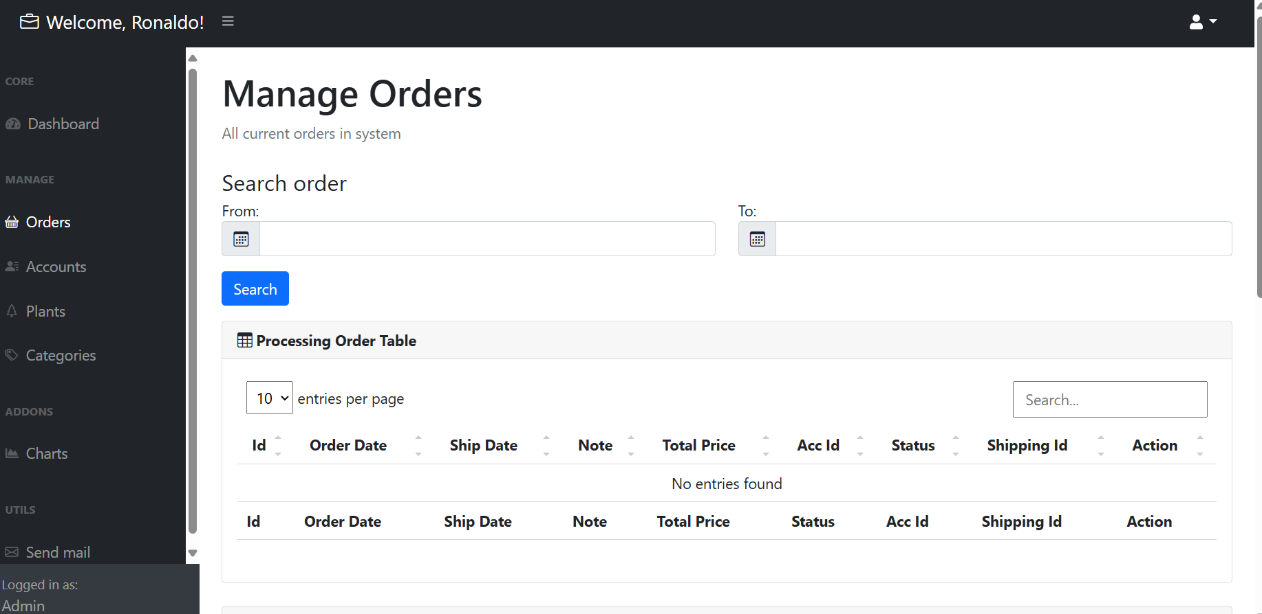

## III. Conclusion

- Achieved Results:

+ The system addresses the store's need for digital product promotion and customer cart management, enhancing convenience and efficiency for both parties without compromising effectiveness.

+ The interface is simple, contemporary, and user-friendly, making it easy for both administrators and customers to navigate and use.

- Limitations: The system still has several shortcomings in terms of functionality, interface, and information security.

- Improvements and Development:

+ Complete the missing and incomplete functionalities, as the current features are quite basic.

+ Optimize the code to enhance website performance.

+ Enhance the shopping cart to support online payments.

+ Improve website security and fault tolerance.

+ Expand with additional application modules/plugins, deploy the website on a host, and assign a domain name.